Purpose of Indicators Used as a quality control indicator to verify transport temperature of blood units has not exceeded 10° C.

Location of Indicators Back of the blood unit in the lower portion of the bag.

DO NOT REMOVE INDICATORS FROM THE BLOOD UNITS
STORED IN BLOOD REFRIGERATORS.
SAFE TO STORE AND TRANSFUSE |  | RETURN TO BLOOD BANK OR TRANSFUSE WITHIN 4 HOURS OF ISSUE TIME ***
<9° C | ~9.5° C | ≥10° C
White or very lightly speckled red | ~50% speckled red | Solid red
 | 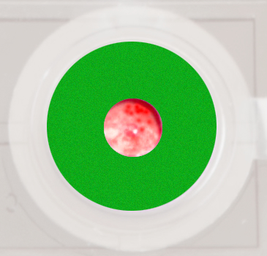 | 
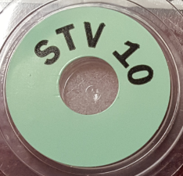 | 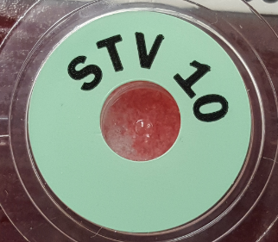 | 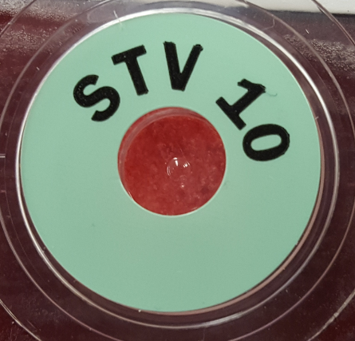

***Blood may be safely transfused to the intended patient within 4 hours of the issue time (stamped on Send Blood Form or consult with BB) even when the indicator is solid red.

Blood units with speckled indicators that are placed in a blood refrigerator may continue to warm up briefly before chilling. The center dot could change to solid red in this time period. Consult with Blood Bank for questions.
Questions? Call Blood Bank at 936-6888.

