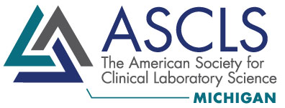

**The American Society for Clinical Laboratory Science-Michigan would like to invite you to attend our annual**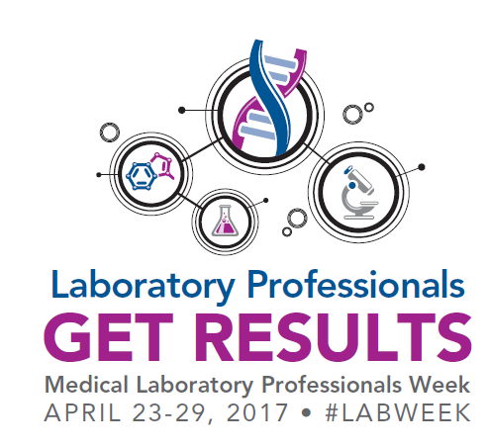

**Lab Week Professional Advocacy Day!**

**Tuesday, April 25, 2017**

**Lansing, MI**

In today's ever-changing healthcare arena, it is vitally important that we, as medical laboratory professionals, meet with our state legislators, to make our role and our importance in healthcare known. This annual Lab Week event gives attendees an exciting, fun opportunity to provide a visible voice for laboratorians statewide! Attendees will visit the offices of their legislators in Lansing to distribute information about our profession while networking with fellow laboratorians from across the state. This event will also include a group recognition of attendees by the Michigan Senate and Michigan House of Representatives, with an optional Wrap-Up Social Hour at a local restaurant to follow.

**Schedule of Events:**

9:00am – Meet in the Lobby of Anderson House Office Building

9:00am – 9:30am –Overview of Day’s Festivities, Organize Office Visit Groups

9:30am – Walk to the Capitol Building

10:00am – 10:30am – Group Recognition by Michigan Senate

10:30am – 1:00pm – Distribution of Materials to Legislators, Office Visits

1:00pm – Meet in the Capitol Building

1:30pm-2:00pm – Group Recognition by Michigan House of Representatives

3:00pm – Post-Event Social Hour, Location TBD (Optional)

**Interested in joining us for this exciting day of advocacy and networking? Please RSVP your name and PERMANENT residential address to Stephanie Rink at** [**Stephanie.Rink@outlook.com**](mailto:Stephanie.Rink@outlook.com) **by Friday, April 21, 2017. Registration is free, but we would like to know how many individuals are coming and from which voting districts, for organizational purposes. Additional details to follow upon registration.**