Click on View from the menu toolbar.

Make sure there is a check mark next to Shortcut Bar in the View tab (if there isn’t, click once to check it).

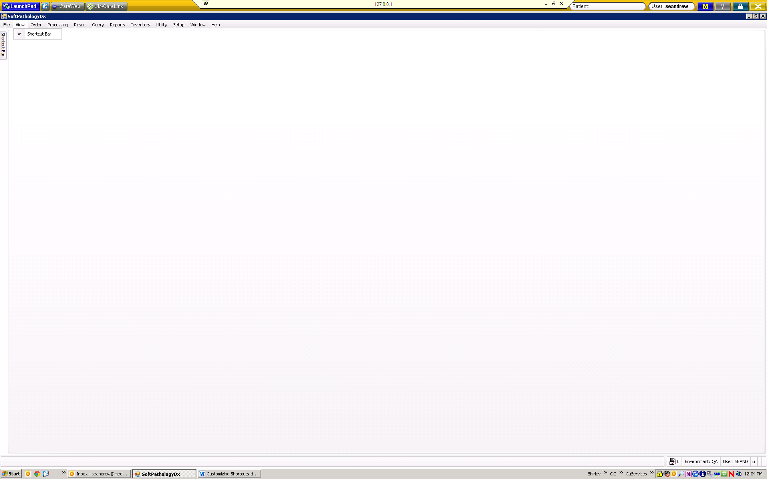

Hover your cursor over the tab on the left side titled “Shortcut Bar.” Your shortcut bar should pop out.

Right click on the white space within the shortcut bar, then click “Customize.”

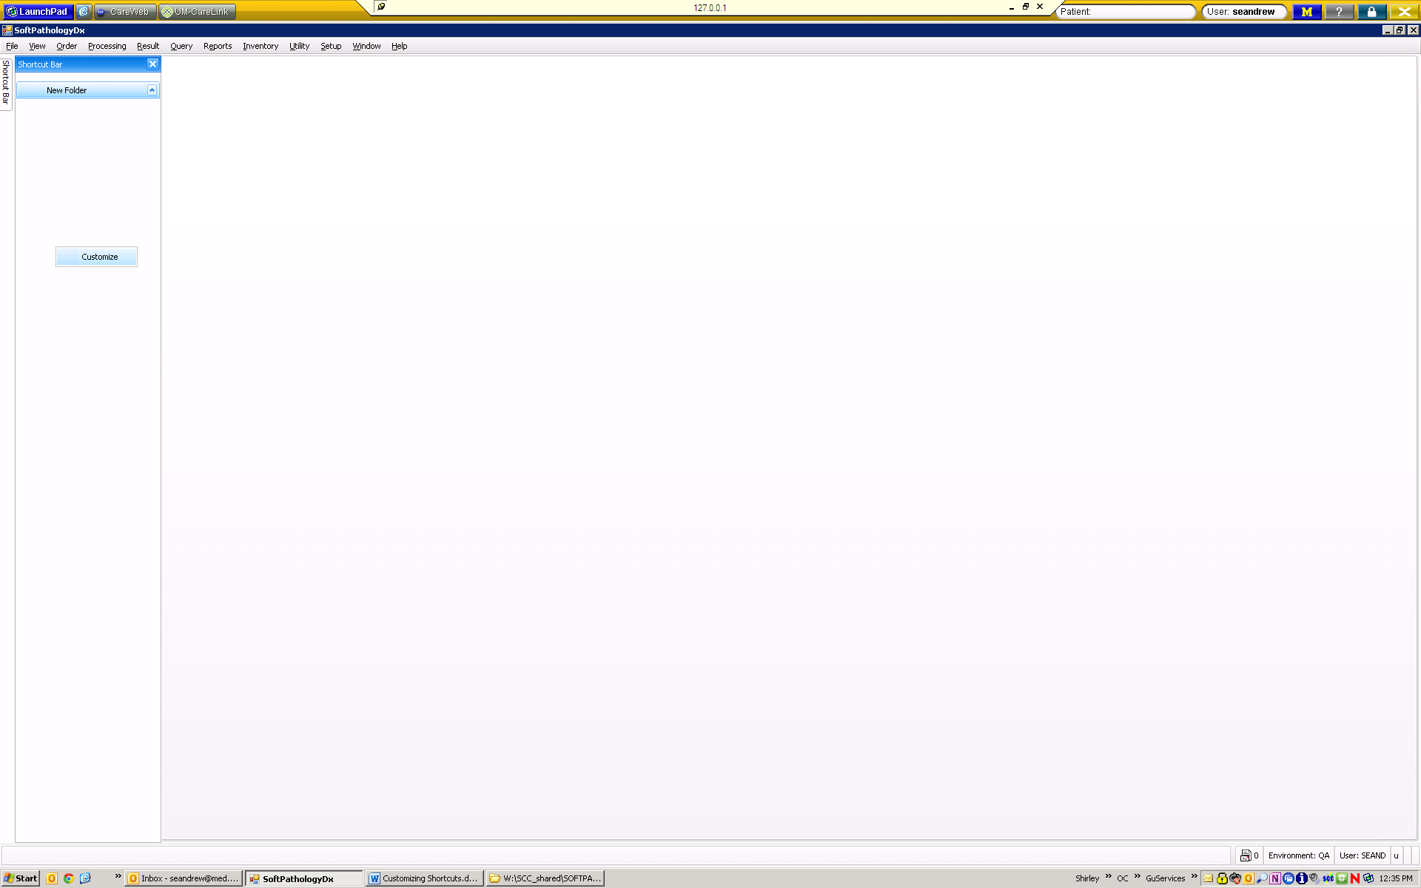

A customization box pops up. In the Folders tab, click “Add.” A “New Folder” should display in the list.

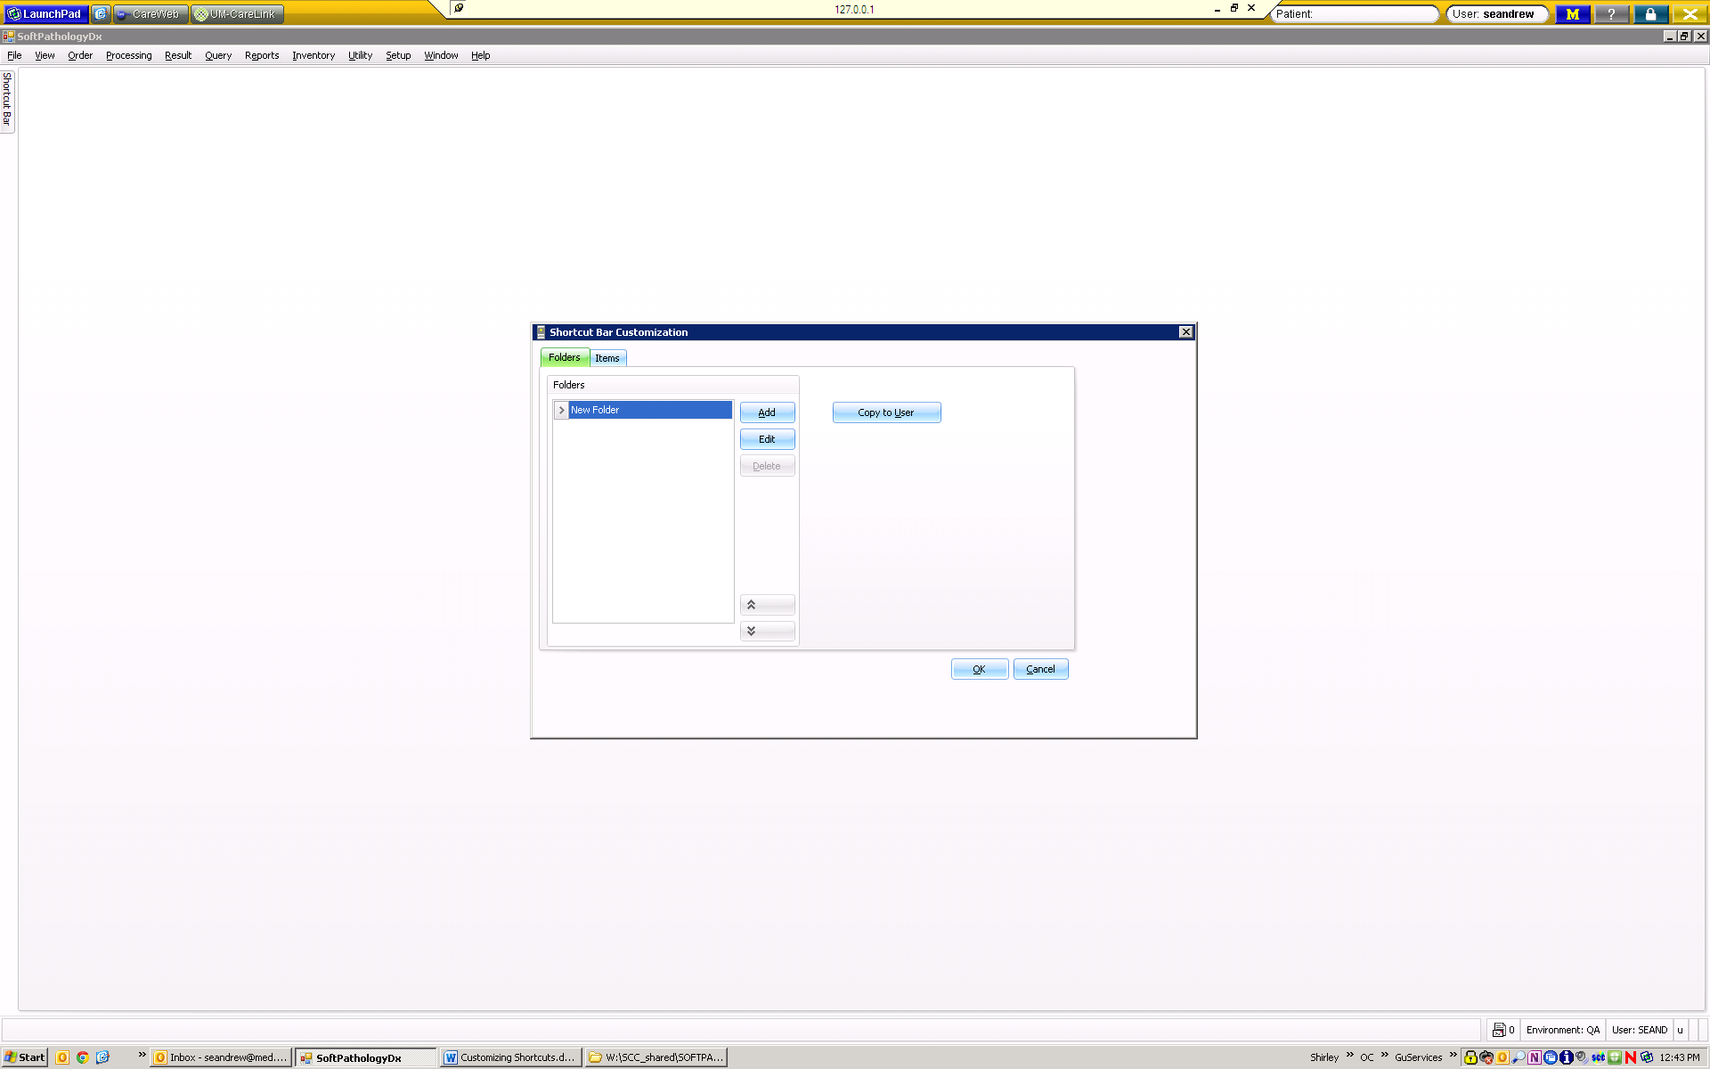

You can click the “Edit” button to rename your folder.

Click the “Items” tab to add shortcuts to your folder.

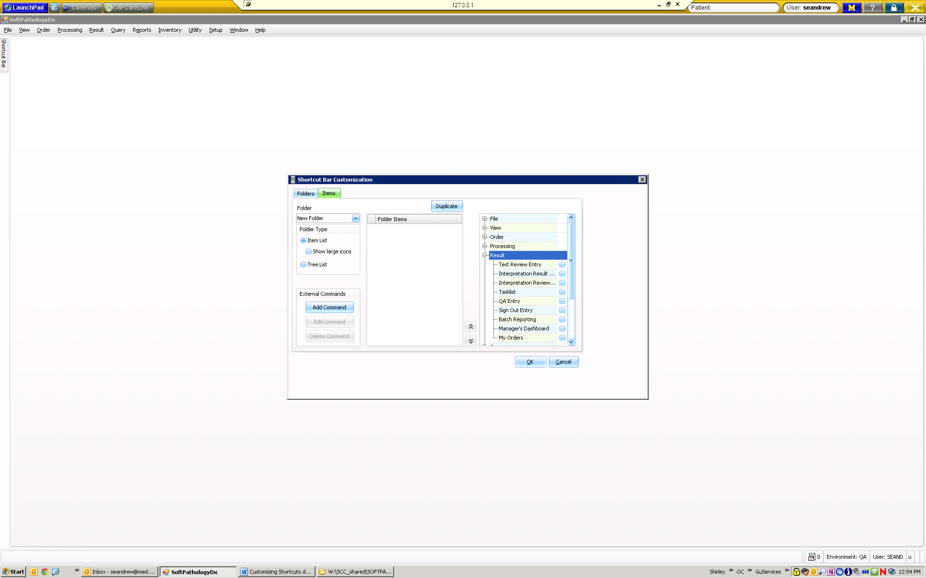

Current folder displayed here

Click the + next to each section to display contents, then check the box next to items you want to include in this folder on your shortcut bar. Click “OK” when done.

|  |  |
| --- | --- |
| **Faculty Shortcut Recommendations:** | **Admin Shortcut Recommendations:** |
| Result > Sign Out Entry | Result > Interpretation Result Entry |
| Result > My Orders | Order > Order Entry |
| Query > Query Result | Reports > Result Reports |
| Reports > Result Reports | Reports > Miscellaneous Reports > Unsigned Orders over 48 Hours Long |
| Utility > Lock Info | Utility > Print Admin Utility |
| Help > Color Schema | Utility > Lock Info |
|  | Help > Color Schema |