**Purpose**

To establish a grossing procedure on how to gross and dictate amputated digits for cutaneous cancer.

**Procedure**

* Take images of digit for documentation and annotation.
* Measure and dictate size of digit along with anatomic structures.
* Measure and describe lesion(s), location, depth of invasion and distance to margin(s).
* Ink resection margins depending on criteria stated below.
* If **lesion is 2.0 cm or greater from margin of resection**, shave skin/soft tissue margins and submit en face. Due to size and anatomy, the grosser should separate margins in different cassettes, i.e. A1. Dorsal half, A2. Ventral half, etc. Ink sections in a way that each half contains two colors, similar to a square excision (i.e. blue=lateral half, black=medial half, etc.). Dot the true margin with red ink so histology knows proper orientation at time of embedding. Bone margin should also be shaved and submitted en face if there is a concern for bone invasion. Section along the short or long axis and describe depth of invasion. Submit entire lesion and at least 1 or 2 sections of adjacent uninvolved skin. Include underlying bone in sections of greatest depth of invasion (be sure to decalcify sections as needed). See diagram below.

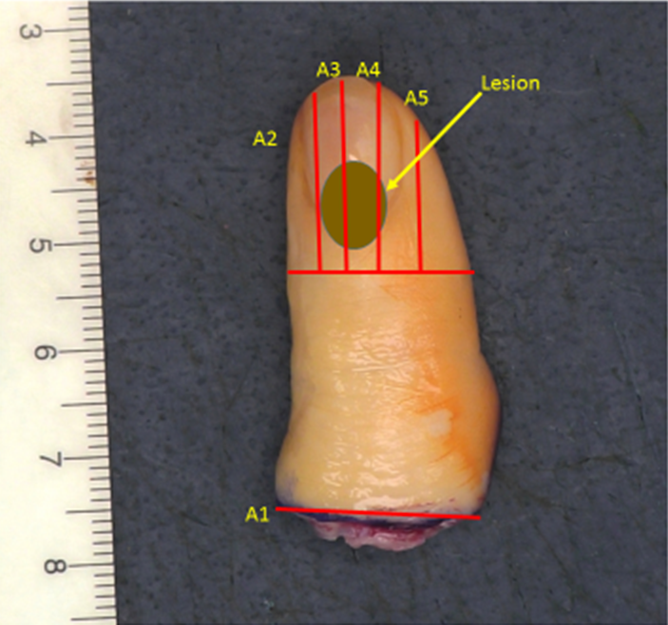

* If **lesion is less than 2.0 cm from margin of resection**, section along the short axis to include perpindicular sections of entire lesion and margin plus 1 or 2 sections of adjacent, uninvolved skin. Describe depth of invasion. Include underlying bone in sections of greatest depth of invasion (be sure to decalcify sections as needed). See diagram below.

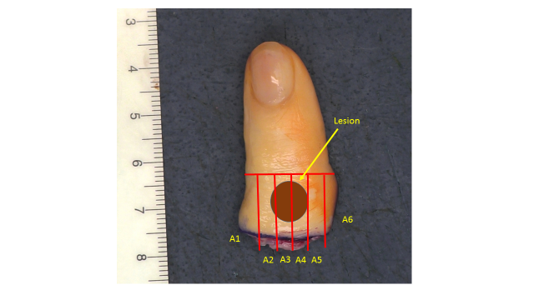

* Describe any other gross abnormalities.
* Annotate your diagram.
* Make sure cassettes that contain bone are properly decaled in Cal-Ex before submitting to histology.

**Sections for Histology**

* If lesion is 2.0 cm or greater from the margin, shave and submit entire skin, soft tissue margin; include shaved bone margin only if invasion is suspected. Generally, the lesion can be submitted in total with 1 to 2 sections of adjacent, uninvolved skin; including underlying bone (3-4 cassettes). If lesion is large, submit 1 section per cm including 1-2 sections of greatest depth of invasion and/or underlying bone.
* If lesion is less than 2.0 cm from the margin, submit perpendicular sections of entire lesion to margin and 1-2 sections of adjacent, uninvolved skin and underlying bone.
* Submit any other abnormalities.