**Purpose**

Hysterectomy for cervical dysplasia (high grade squamous dysplasia/adenocarcinoma in situ)

**Specimen: Uterus with attached cervix, with or without attached adnexae**

**Procedure**

**Handling**

a) First, weigh the fresh specimen and identify the anterior and posterior aspects of the uterus. If adnexa are present, measure tubes and ovaries, identifying as right and left, keeping with uterus for sampling.  
  
b) Ink vaginal margin: This margin may be a small cuff of vaginal mucosa surrounding cervix, if it is not apparent, call the GS attending or fellow for help.  
  
c) If received fresh, amputate cervix below the isthmus and handle like a fresh cone specimen. This section should be a size that can fit into a cassette (approximately 2.5 cm)  
  
d) If received fixed, amputate the cervix below the isthmus  
  
e) Open supracervical uterus along the lateral borders (like a usual hysterectomy specimen) and fix overnight  
  
**Description**

a) Cervix

1. Dimensions of ectocervix, length of endocervical canal
2. Lesion location, size, thickness, and distance from deep margin
3. Appearance of the remainder of the ectocervix and endocervix

b) Uterus

1. Uterine weight, dimensions (superior to inferior, cornu-to-cornu, and anterior-to-posterior)

1. Thickness of endometrium, thickness of myometrium, appearance of serosa
2. Incidental lesions (polyps, leiomyomas)

c) Ovaries and fallopian tubes: As described under benign ovarian disease.

**Sections**

a) Cervix (remember it's for neoplasia!):

1. Since some cervical lesions are not grossly visible and invasive/microinvasive disease need to be ruled out, the entire cervical mucosa should be submitted for histologic evaluation.
2. Submit all sections from each quadrant of the cervix as you would for a cone specimen. Include appropriate representations of the squamocolumnar junction and its relationship to the lower uterine segment.
3. It is possible that sections of the cervix as submitted above will not capture the entirety of the transformation zone. Therefore, submit one section per quadrant of upper endocervix/lower uterine segment (e.g. 12:00, 3:00, 6:00, and 9:00 positions).

b) Uterus:

1. Submit a full-thickness “T” sections from the anterior and posterior endomyometrium as shown below

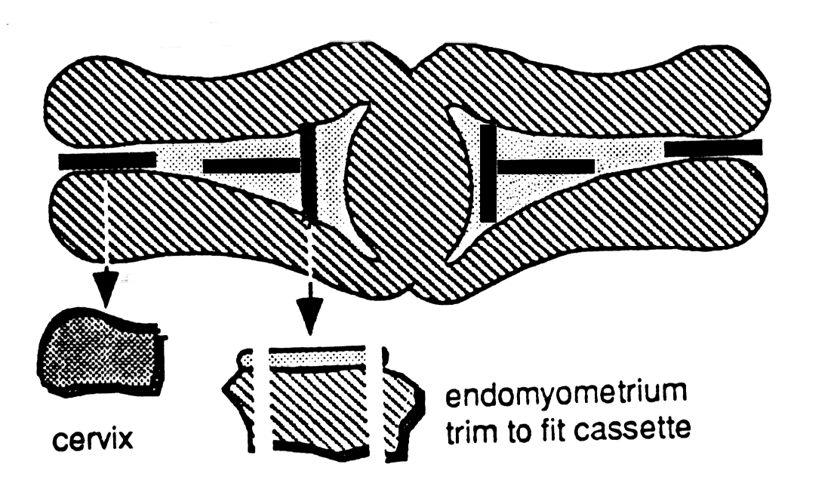

1. Representative section(s) of any additional myometrial or serosal lesions

c) Ovaries and fallopian tubes: As described under benign ovarian disease

Radical hysterectomy for cervical carcinoma  
**All tumors should be procured fresh for tumor bank purposes as per protocol**

The specimen consists of a uterus, cervix, a portion of vaginal mucosa (vaginal cuff), right and left parametria (soft tissue with vessels) and may include adnexa

**Handling**

a) If adnexa are present, measure tubes and ovaries, identifying as right and left, keeping with uterus for sampling.  
  
b) Ink vaginal cuff margin  
  
c) Weigh the fresh specimen  
  
d) Dissect the lower uterine segment parametria down to the cervix, separate and keep right and left sides properly labeled for later sectioning and identification in the slide key.  
  
e) Amputate the cervix (with attached parametria) from the uterus. Do not amputate too low, especially if an endocervical lesion is suspected. If uncertain, please consult the gynecologic pathology fellow and/or attending pathologist.  
  
f) Open the anterior cervix at 12:00 and pin out on Styrofoam or cardboard to fix overnight  
  
g) Open supracervical uterus along lateral borders and fix overnight

**Description**

a) Cervix:

1. Dimensions of ectocervix, length of endocervical canal
2. Lesion: Size, relationship to endo- and ectocervix (squamocolumnar junction), thickness (depth of invasion), distance from margins (vaginal cuff and deep soft tissue), color, consistency, growth pattern (endophytic or exophytic), necrosis, and hemorrhage

b) Uterus:

1. Length, width, thickness of endometrium, thickness of myometrium, appearance of serosal surface
2. Lesions: Uterine polyps, leiomyomata, adenomyosis

c) Ovaries and fallopian tubes: As described under benign ovarian disease

**Sections (see diagram)**

a) Parametria:

1. Separate the right and left parametria from the cervix and submit entire parametria in as many cassettes as necessary (this constitutes a true surgical margin)

b) Vaginal cuff:

1. If distant from the tumor (greater than 1.5 cm), a shave margin can be submitted of the entire vaginal cuff.
2. The shave margin should be thin (3-4 mm) and can be placed in cassette with incised surface facedown.
3. Remember that any tumor in a shave margin is a "positive" margin. If within 1.5 cm of tumor, DO NOT attempt to shave margin, section the margin perpendicularly toward the nearest point of the tumor to the margin and submit in a single cassette

c) Cervix:

1. If Gross Tumor Is Visible: Four sections of tumor should include the closest approach of tumor to the vaginal cuff and deep margins (if these sections are large, they can be bisected and placed in 2 consecutive cassettes, ink the bisected edges to assist orientation during microscopic review)

(a) Digital photography of the tumor is highly recommended; adding annotations that represent individual cassettes/slides   
  
(b) Include sections representing deepest point of invasion  
  
(c) One random section from each quadrant of remaining uninvolved cervix

1. If No Obvious Tumor Is Visible: Submit cervix in its entirety as described above for HSIL/AIS

(a) If there are any questions regarding the number of sections to be taken, please discuss with the gynecologic pathology fellow or attending pathologist for the case

d) Uterus:

1. At least one full-thickness longitudinal section from each quadrant of the upper endocervix/lower uterine segment should be submitted. If tumor is obviously present in endocervix or extends into the lower uterine segment, then include appropriate representations of the squamocolumnar junction and its relationship to the lower uterine segment.
2. Full-thickness “T” sections from the anterior and posterior endomyometrium
3. Incidental lesions should also be included

e) Ovaries and fallopian tubes: As described under benign ovarian disease

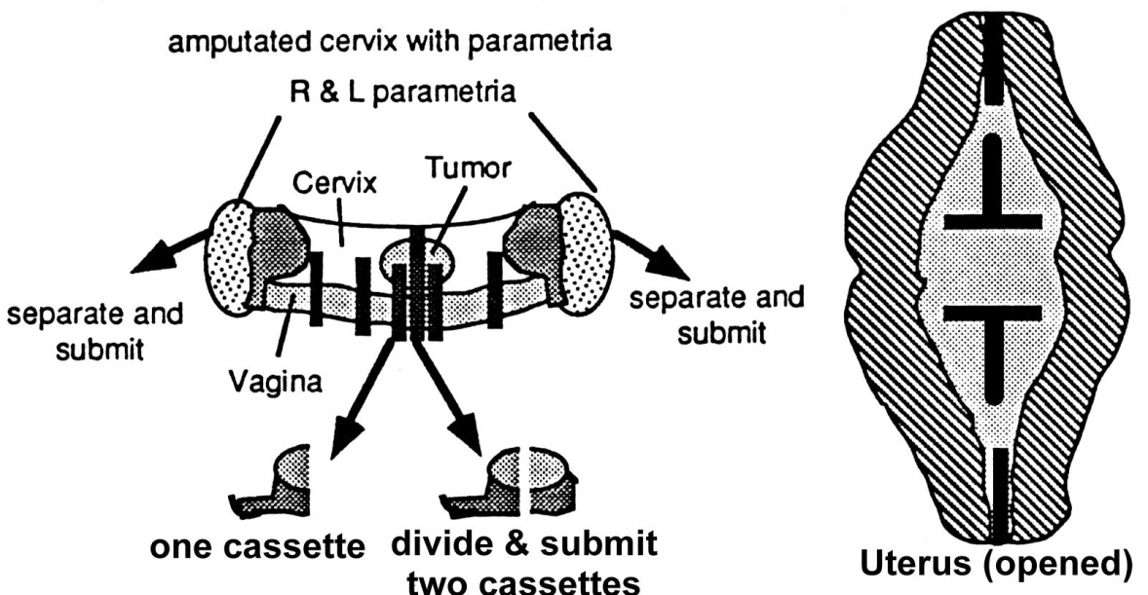

Hysterectomy for benign disease (leiomyomata, prolapse, etc)

The specimen will usually consist of the corpus with attached cervix, with or without adnexa

**Handling**

a) Identify anterior and posterior: Ovaries (utero-ovarian ligament) are posterior to the round ligament, the anterior peritoneal reflection (bladder reflection) is higher than the posterior peritoneal reflection which is often more ragged in appearance  
  
b) If adnexa are present, measure tubes and ovaries, identifying as right and left, keeping with uterus for sampling.  
  
c) Weigh the fresh uterus and cervix  
  
d) Open the uterus along the parametrial border using the endocervical and endometrial canal as a guide for incising in the proper tissue plane. Straight blade or sharp scissors are preferred over a scalpel or dissecting blade (which can inadvertently slice the myometrium in the improper plane). If difficulty is encountered, the attending pathologist or gynecologic pathology fellow should be consulted.  
  
e) If large leiomyomas are present, measure and bread-loaf the uterus and fibroids prior to fixation allowing them to fix overnight. Note the contours of the leiomyomas with respect to the surrounding myometrium. Normal, benign leiomyoma to should have a white, whorled appearance on cross-sections. Note any unusual changes from this normal appearance such as hemorrhage and necrosis; if seen, taking photographs of these areas is strongly encouraged.

**Description**

a) Cervix:

1. Width, and thickness, length of endocervical canal, and appearance of ectocervix, transformation zone, endocervical canal (erosions, hemorrhage, polyps, cysts)

b) Uterus:

1. Length, width, appearance of endometrium (color, hemorrhage, thickness, polyps), thickness of myometrium, appearance of serosal surface
2. Leiomyomata: Number, location (subserosal, intramural, submucosal, or pedunculated), size (range of sizes if multiple), consistency, presence of hemorrhage, necrosis, discoloration, or calcification

c) Adnexa: As described for benign ovarian disease

**Sections**

a) If no obvious (gross) pathology:

1. One section from each:

(a) Anterior and posterior cervix;  
  
(b) Full-thickness anterior and posterior endomyometrium (transverse T-section preferred)

b) Leiomyomas are present, with uniform (whorled, white ~ benign) appearance without evidence of hemorrhage or necrosis:

1. One section to represent small myomas (less than 3 mm in size) and one section from each myoma >3 centimeters. For uteri with very many leiomyomas, use your judgment or contact your fellow or attending to avoid excessive block submission.

c) Leiomyomas present with evidence of necrosis, hemorrhage, soft consistency, or infiltrating borders:

1. Digital photography is strongly encouraged!!!
2. Submit one section for every centimeters of the largest tumor diameter, sampling abnormal areas, including sections of the myoma-myometrial interface

d) Adnexa: As described for benign ovarian disease   
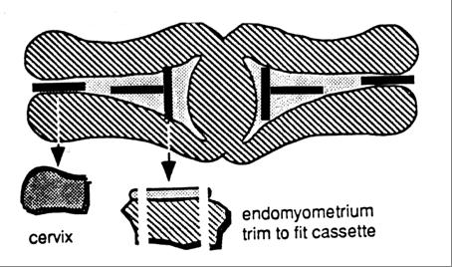

Hysterectomy for endometrial hyperplasia, endometrial carcinoma, or malignant mixed Müllerian tumor  
The specimen will usually consist of a uterus, attached cervix, with or without adnexa

**Handling**

a) Identify anterior and posterior: Ovaries (utero-ovarian ligament) are posterior to the round ligament, and the anterior peritoneal reflection (bladder reflection) is higher than the posterior peritoneal reflection  
  
b) a) If adnexa are present, measure tubes and ovaries, identifying as right and left, keeping with uterus for sampling.  
  
c) Weigh the fresh uterus and cervix  
  
d) Open the uterus along the lateral borders (3 and 9 o’clock) using the endocervical and endometrial canal as a guide for incising in the proper tissue plane. Straight blade, sharp scissors are preferred over a scalpel or dissecting blade (which can inadvertently slice the myometrium in the improper plane)  
  
e) For polypoid cancers such as mixed Müllerian tumors it is common to have a large polypoid mass expanding the uterine cavity. In these cases it is best to carefully open the uterus along the lateral borders using **sharp scissors**, opening in increments from the endocervical os at 3 and 9 o’clock all the way to the uterine fundus, taking care not to disrupt the polypoid mass within the cavity.  
  
f) Digital photographs of the fresh and fixed specimen are strongly encouraged, as is annotating sections with specimen labels  
  
g) Allow specimen to fix overnight

**Description**

a) Uterus:

1. Weight, dimensions (superior to inferior, anterior to posterior, cornu to cornu)
2. Lesion: Size, location (anterior, posterior, fundic), involvement of the lower uterine segment or cervix, color, consistency, gross assessment of depth of invasion (inner or outer one half of myometrium), involvement of serosal surface
3. Appearance of uninvolved endometrium, myometrium (including myometrial thickness) and serosal surface
4. For an exophytic tumor, measure tumor dimensions and the distance of deepest tumor to serosa
5. If you can grossly assess the depth of invasion, it should be measured from the endomyometrial junction to the deepest point of myometrial invasion.

b) Cervix

1. Width of ectocervix, length of endocervical canal, appearance of mucosa (polyps, ulceration, cysts, masses)

c) Adnexa: As described for benign ovarian disease

**Sections**

a) Uterus/cervix:

1. If a Lesion Is Seen Grossly: At least 4 sections of tumor (including the deepest tumor invasion-see diagram for transverse T-sections). These sections should be full endomyometrial thickness-sections (from the endometrial cavity to serosa). If necessary these sections should be split into one or more consecutive cassettes (consider a whole mount). Ink bisected edges to assist orientation of sections during microscopic review
2. If no tumor is seen, submit at least four full thickness sections of endomyometrium. Remaining endometrium should be entirely submitted, but these sections do not need to be full thickness (sufficient to include endometrium and superficial 2-3 mm of underlying myometrium) and more than one piece of tissue can be placed in a cassette.
3. One section of anterior cervix and lower uterine segment (placed in 2 consecutive cassettes if necessary)
4. One section of posterior cervix and lower uterine segment (placed in 2 consecutive cassettes if necessary)

Hysterectomy for uterine leiomyosarcoma or stromal sarcoma

**Handling**

a) Process adnexa as for previous hysterectomy specimen, handling as described for benign ovarian and tubal disease  
  
b) Weigh the fresh uterus and cervix with adnexa removed  
  
c) Open cervix and uterus along parametria laterally, using cervical os as a guide for staying within the lumen of the endocervix and endometrial cavity  
  
d) If a large tumor is present in the myometrium, or multiple tumors are present, the cavity may be difficult to identify.

1. A helpful technique is to place two probes in the endocervix/uterus and carefully cut along the parametrial borders (3 or 9 o'clock axis). Starting at the cervix and working toward the endometrial cavity will allow better perspective as to where the endometrial cavity might be, even if the anatomy is markedly distorted

e) Bread-loaf the larger tumor(s) and place the entire specimen in formalin for fixation. Photograph the specimen.

**Description**

a) Uterus: Weight, dimensions (superior to inferior, anterior to posterior, cornu to cornu)

1. Tumor: Size, location, color, consistency, presence of necrosis, hemorrhage, areas of discoloration or calcification, tumor-myometrial junction with any visible evidence of infiltrative growth or intravascular intrusion/protrusion, involvement of serosal surface
2. If pedunculated, measure the size of the tumor base (sessile, elongated with or without portion). Any extension to the lower uterine segment or cervix should also be noted Appearance and thickness of endometrium, myometrium, serosal surface, other lesions, and degree of distortion of endometrial cavity

b) Cervix: Width, thickness, length of endocervical canal, appearance of ectocervix, transformation zone, endocervical canal erosions, hemorrhage, polyps or cysts.

c) Adnexa: As described for benign ovarian disease

**Sections**

a) Uterus/cervix:

1. Tumor: At least one section of tumor sampled for every centimeters of largest tumor diameter (include tumor borders, central areas, hemorrhagic areas, and areas bordering necrotic sites). (For very large tumors use your judgment or contact your fellow or attending to avoid excessive block submission.)
2. One section of anterior cervix and lower uterine segment (placed in 2 consecutive cassettes if necessary)
3. One section of posterior cervix and lower uterine segment (placed in 2 consecutive cassettes if necessary)
4. Uninvolved endomyometrium (full-thickness)

b) Adnexa: As described for benign ovarian disease