Purpose
The purpose of this entry is to establish a procedure on how to gross distal pancreatectomies.
Distal pancreatectomies (distal pancreas and attached spleen) are usually performed for neuroendocrine tumors and non-neuroendocrine tumors (e.g., serous cystadenomas or mucinous cystic neoplasms), and sometimes for non-neoplastic cysts (e.g., congenital cysts or pseudocysts) or chronic pancreatitis. In addition, it can also be performed for pancreatic adenocarcinomas of the body/tail. However, adenocarcinomas involving the distal pancreas are more common to present at an advanced stage.

Procedure
- Record the size of the distal pancreas and spleen. If the spleen is uninvolved by tumor, separate from the pancreas and weigh it.
- Examine the external specimen. Look for evidence of tumor (hardness, nodularity, fibrosis, puckering).
- If tumor is grossly involving the pancreatic external surface, ink the focal area that’s involved.
- If it hasn’t already been evaluated intraoperatively, shave and submit the pancreatic resection margin en face. If the tumor is close to the pancreatic resection margin, shave and take perpendicular sections.
- Serially cross section the pancreas and examine the cut surfaces. Document the presence of any lesions, noting size, color, solid or cystic, mucinous or serous, borders (circumscribed/ infiltrating), and location (body or tail). Measure the distance to the proximal resection margin. Note any invasion outside of pancreas including spleen, blood vessels, etc. Describe the appearance of the uninvolved pancreatic parenchyma (soft, yellow-tan, and finely lobulated, or firm, pale-yellow, and finely nodular). See Sample Photographs for details.
- Mucinous cystic lesions that are suspected to be IPMN or MCN should be completely submitted if small or < 20 cassettes; or sampled extensively if large and include any solid areas or thickened walls. Note the relationship of the main pancreatic duct to the cyst – does the cyst communicate with the duct? Non mucinous cystic lesions should be submitted representatively (1 section per cm or at least 5 sections).
- Examine the peripancreatic and splenic hilar soft tissue for lymph nodes. Submit all lymph nodes, making sure to note in your cassette summary where your lymph nodes came from (pancreatic soft tissue or splenic hilum).
- Serial section the spleen and examine the cut surfaces for any lesions. If unremarkable, submit 1 representative section. If the splenic vein is included with the specimen, look for thrombosis or tumor and sample appropriately.

Sections for Histology
- If not already submitted as a frozen, shave and submit the pancreatic margin en face (if tumor is >2cm) or serial section radially (if tumor is <2cm). Submit entire margin.
- Cystic lesions that are suspected to be mucinous cysts less than 5 cm should be submitted entirely. Mucinous cystic lesions greater than 5 cm, submit representative sections up to 20 cassettes (or consult the signing GI pathologist), focusing on papillary excrescences, solid areas and nodules.
- Solid or cystic lesions less than 2cm, submit the entire lesion. Solid or cystic lesions (not mucinous cysts) over 2 cm, submit 1 section per cm or at least 5 representative sections.
- Submit any incidental pancreatic lesions.
- Submit all lymph nodes.
- Submit at least 1 section of spleen and any other splenic abnormalities.
Sample Dictation
“Pancreas and spleen” Received in formalin is a distal pancreatectomy specimen, consisting of: body and tail of pancreas (13.0 x 6.0 x 3.5 cm) with attached spleen (9.0 x 6.0 x 3.8 cm; 142 g).
The pancreas is remarkable for a 3.0 x 2.7 x 2.7-cm, tan-white, fleshy, lobulated, and well-circumscribed mass, located in the body of the pancreas, 1.0 cm from the pancreatic resection margin. The mass abuts—but does not invade—the spleen.
The uninvolved pancreatic parenchyma is pale-yellow, fibrotic, and finely nodular (grossly consistent with chronic pancreatitis). The spleen has unremarkable, dark red-brown, homogenous parenchyma. Five (5) lymph node candidates are identified (0.1 to 0.5 cm in greatest dimension), 3 in the peripancreatic soft tissues and 2 in the splenic hilum.
Inking code: pseudo pancreatic resection margin=orange
Cassette summary:
AFS1 & AFS2. Pancreatic margin shaved and sectioned perpendicular to the tumor (2 ns ea.)
A3-A5. Remainder of tumor, including adjacent uninvolved pancreatic parenchyma (1ns ea.)
A6. Uninvolved pancreatic parenchyma (1ss)
A7. Spleen (1ss)
A8. Lymph nodes from splenic hilum, submitted intact (2ns)
A9. Two (2) lymph nodes from peripancreatic soft tissue, bisected (1 inked blue) (4ns)
A10. One (1) intact lymph node from peripancreatic soft tissue (1ns)

Sample Photographs
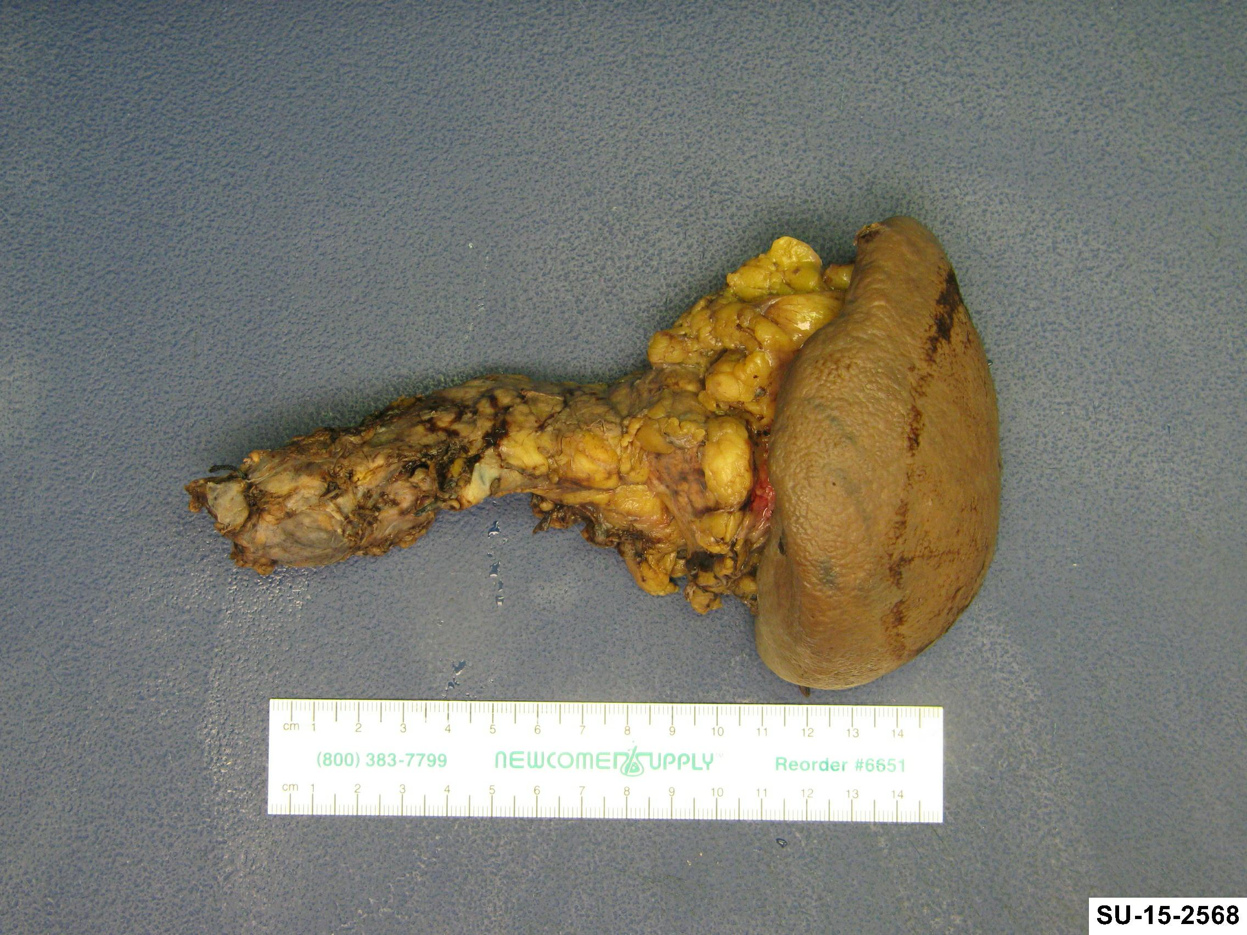
Anterior view of pancreatectomy specimen.

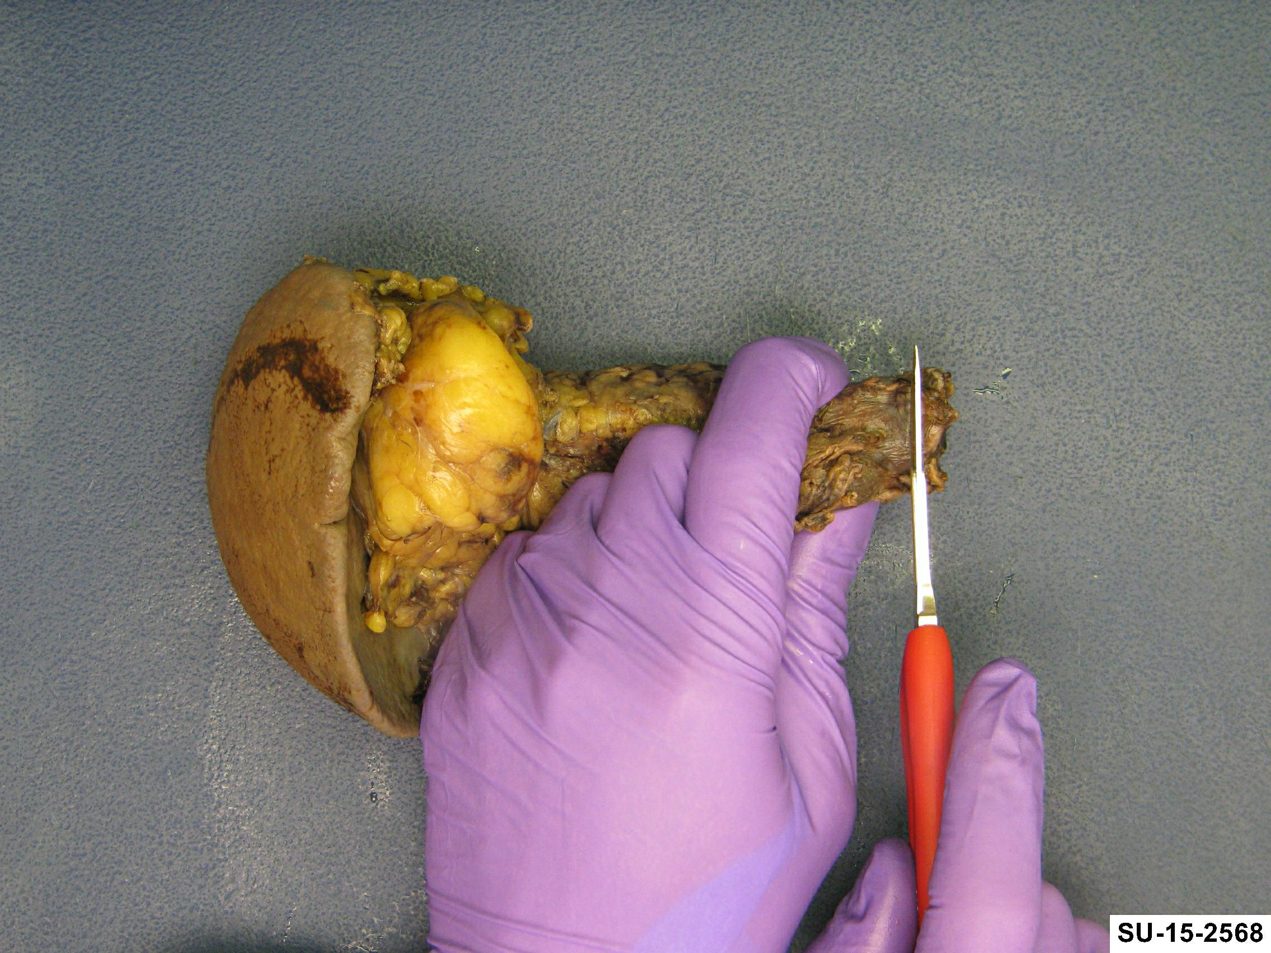
If not submitted already for frozen section control, shave pancreatic margin and submit en face or radially section depending tumor relationship.

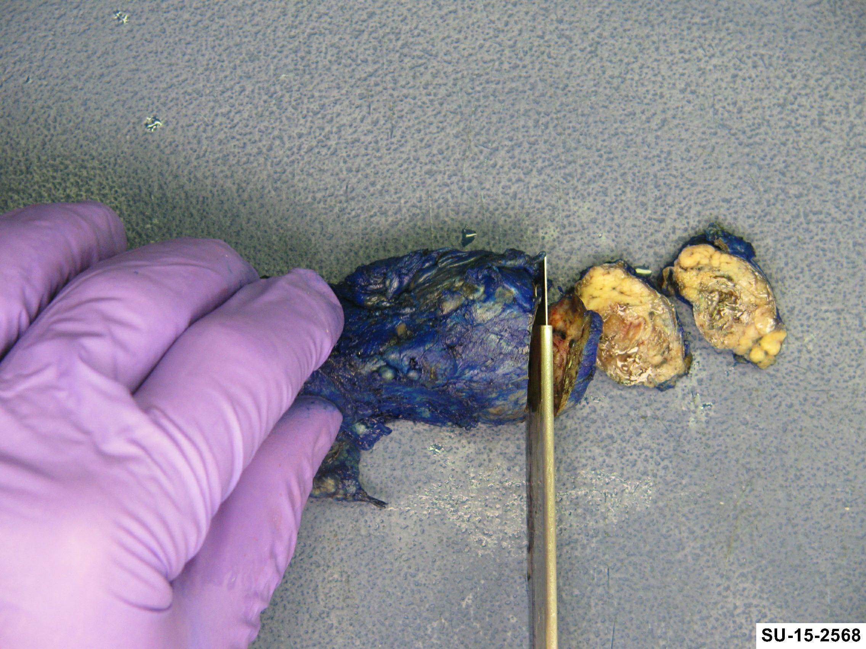
Serial section the specimen along the long axis.

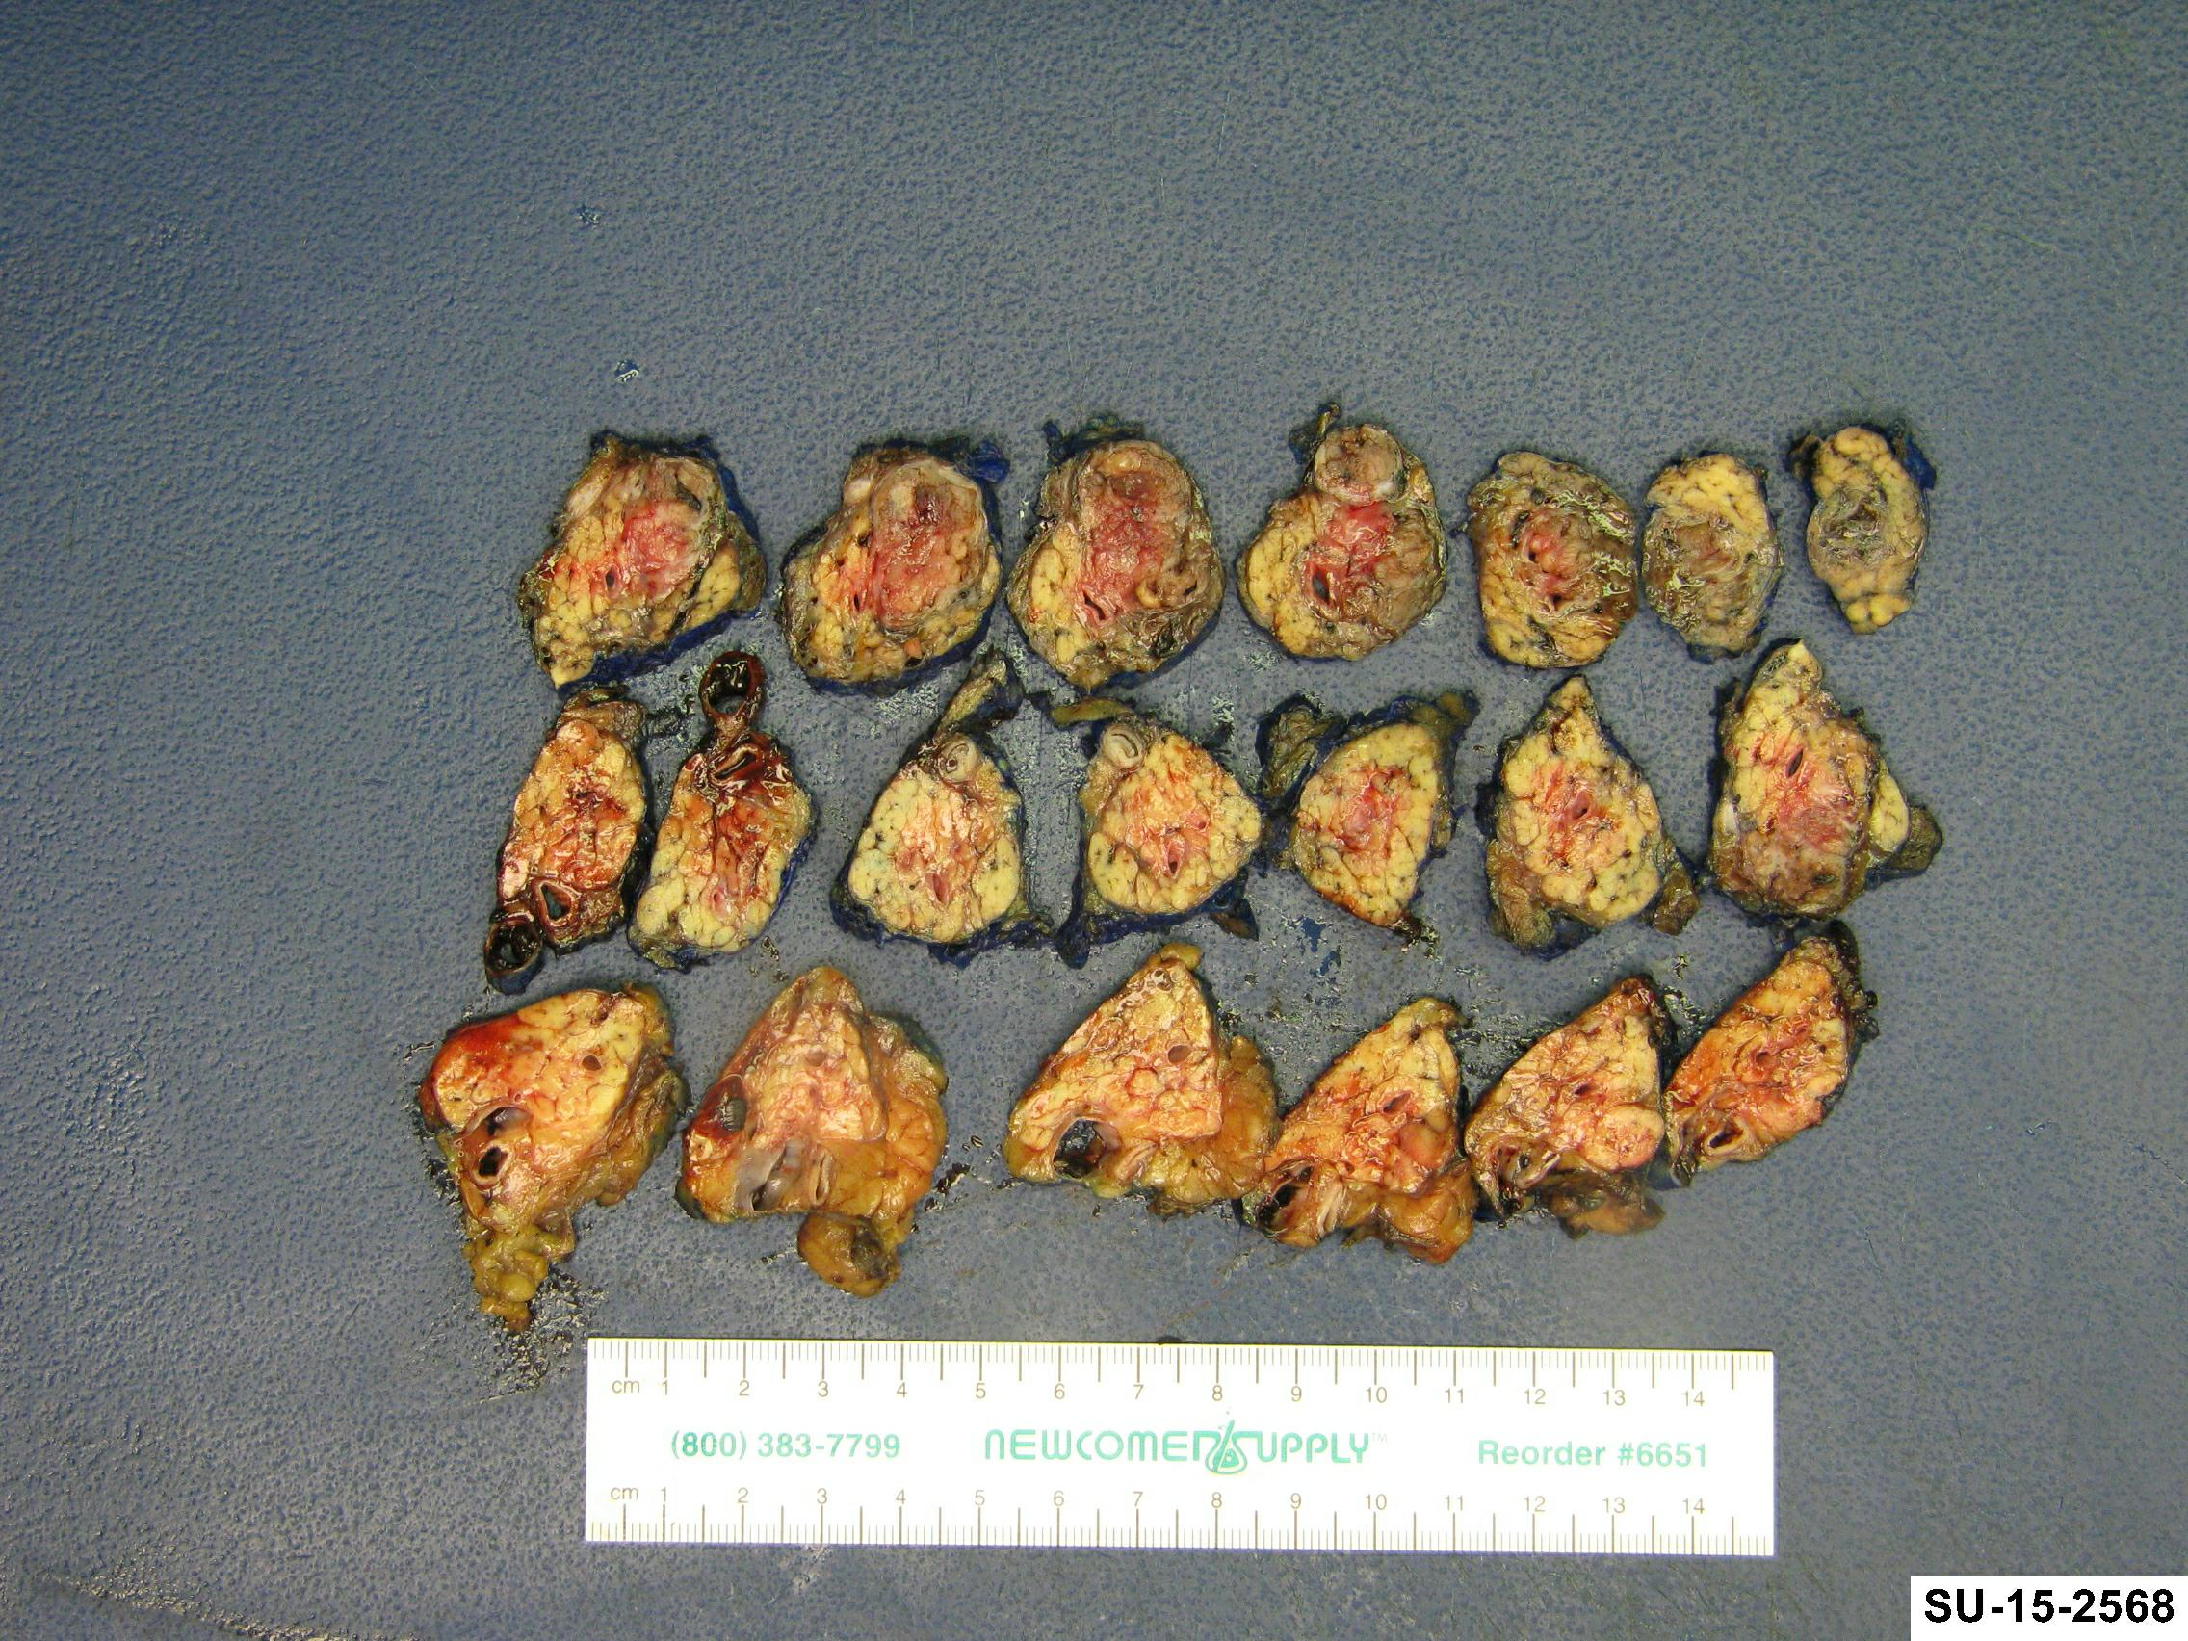
Lay out all sections and take photographs including close ups of the lesion.

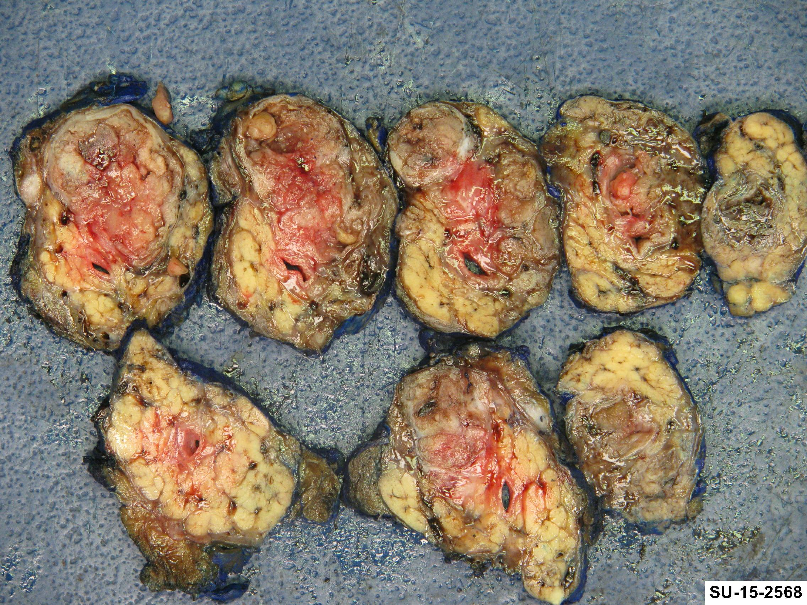

References
Kumar V, Abbas A, Fausto N. Robbins and Cotran Pathologic Basis of Disease. Seventh Edition. Philadelphia, PA: Elsevier Saunders; 2005.
Lester SC. Manual of Surgical Pathology. Second Edition. Elsevier Churchill Livingstone; 2006.

