**Purpose**

To establish a procedure on how to gross different neck dissections. A neck dissection is a surgical procedure to remove selective or all lymph nodes and other certain structures of the neck (i.e. jugular vein) to evaluate for nodal metastasis.

**Definitions**

Radical Neck Dissection: includes Levels I through V, submandibular gland, sternocleidomastoid muscle, internal jugular vein, and spinal accessory nerve

Modified Radical Neck Dissection: Includes Levels I through V, while sparing at least one of the anatomic structures in the radical neck dissection (submandibular glans, sternocleidomastoid muscle, jugular vein, and nerve)

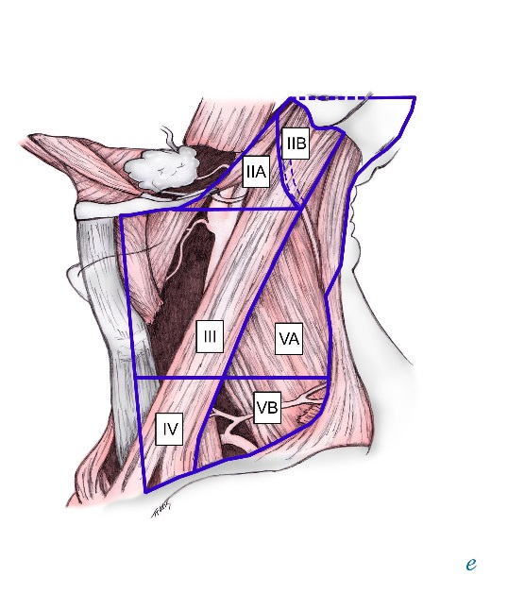Selective Neck Dissection (**Most Common**): removal of select levels, with or without associated anatomic structures (submandibular glans, sternocleidomastoid muscle, jugular vein, and nerve)

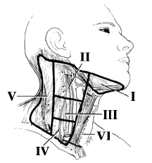

Figure 1 Figure 2

**Procedure**

1. State appropriate type of dissection, measure in three dimensions and note any attached structures, if applicable.

2. Orient the specimen and divide into appropriate levels:

* + Laterality and what levels are submitted should be clearly labeled on the container. (example: “right neck levels 1-4”)
  + The submandibular gland is always attached to level 1. Dissect away the gland and surrounding adipose. Divide the remaining adipose tissue into levels as per Figures 1-2.

TIP: The internal jugular vein and sternocleidomastoid muscle run parallel with levels 2-4.

* + If level 1 is not resected and you are left with any levels spanning from 2-5 and no orientation is provided; clearly state this in the gross and treat the specimen as a regional lymph node dissection.

3. Palpate and dissect all lymph nodes, keeping the levels separate. Evaluate for any extra nodal extension into the adjacent anatomic structures if received (submandibular glans, sternocleidomastoid muscle, jugular vein, and nerve). If nodes are matted, try to separate them out as best as you can.

4. Keep nodes organized into levels and submit in groups (level 1, level 2, etc.).

5. Separately wrap up adipose from each level and label in case you must go back to submit more. State in your dictation the adipose, muscle or remaining tissue retained.

**Sections for Histology**

* Submit all lymph nodes identified.
  + If grossly positive, submit one representative section of that node.
  + Submit all benign appearing lymph nodes entirely.
* Submit up to six lymph nodes per cassette of the same size (if less than 0.8cm).
* If nodes are larger (between 0.8 and 1.4 cm), bisect them and submit up to 2 nodes in a cassette. Please make sure you ink one of them before you bisect so you can distinguish under the scope.
* If nodes are larger than 1.4 cm, serial section and place in own cassette (s).
* Submandibular gland if present in one cassette
* Tumor involving or extending to the submandibular gland, muscle or vein/ nerve, represent this in one cassette
* NOTE: If no nodes are identified in a level, submit up to three cassettes of adipose. Do not submit muscle as no nodes will be located in this tissue.

**Gross Description**

1. “Left neck Levels I-III” received in formalin in a small container is a 6.3 x 3.4 x 1.6 cm selective neck dissection. Within level 1 is a 2.2 x 1.8 x 1.1 cm unremarkable submandibular gland and four possible lymph nodes ranging from 0.3 – 0.4 cm. Level 2 contains twelve possible lymph nodes ranging from 0.2 – 1.3 cm in greatest dimension. Level 3 contains five possible lymph nodes ranging from 0.2 – 0.6 cm in greatest dimension.

Cassette Summary:

A1-2 Level I

A1. Submandibular gland. (1ss)

A2. Four possible lymph nodes submitted whole. (4ns)

A3-6 Level II

A3. Six possible lymph nodes submitted whole. (6ns)

A4. Three possible lymph nodes submitted whole. (3ns)

A5. Two possible lymph nodes submitted whole. (2ns)

A6. Largest, grossly positive lymph node. (1ss)

A7-8 Level III

A7. Four possible lymph nodes. (4ns)

A8. One possible lymph node, bisected. (2ns)

Fat retained.

1. “Right neck Level IV” received in formalin in a small container is a 2.5 x 1.8 x 0.8 cm selective neck dissection. Sixteen possible lymph nodes are identified ranging from 0.2 cm to 1.8 cm in greatest dimension. Sectioning through the largest lymph node reveals matted, grossly positive cut surfaces (containing possibly three nodes).

Cassette Summary:  
A1. six possible intact lymph nodes. (6ns)

A2. four possible intact lymph nodes. (4ns)

A3-5. each contain one possible lymph node, bisected. (2ns each)

A6-7. each contain one possible lymph node, bisected. (2ns each)

A8-9. each contain one possible lymph node, bisected. (2ns each)

A10. representative section of matted lymph nodes. (3ss)

Fat retained.

**â¢ In the case of intraosseous lesions, record
whether the lesion has caused expansion
and/or attenuation of adjacent corti...Sample Image of Left neck dissections levels 1B-V**

**References**

https://emedicine.medscape.com/article/849834-overview?pa=l%2FeFIzALpGOWp5xHt2Io95RuBUjuoPX1JhO%2FkqzaOeOR8AIQGcFdP3jB2SfRL8NuBBfl7NjjjGBbDWyAO2%2BWXeejCO3Rk4DWsD37DrSZWvU%3D#a3

https://www.slideshare.net/bkpranav/grossing-of-mandibulectomy-specimen-dr-pranav-mgims