**Ordering stains at time of grossing**

Click “proc req” at the top right of the screen.

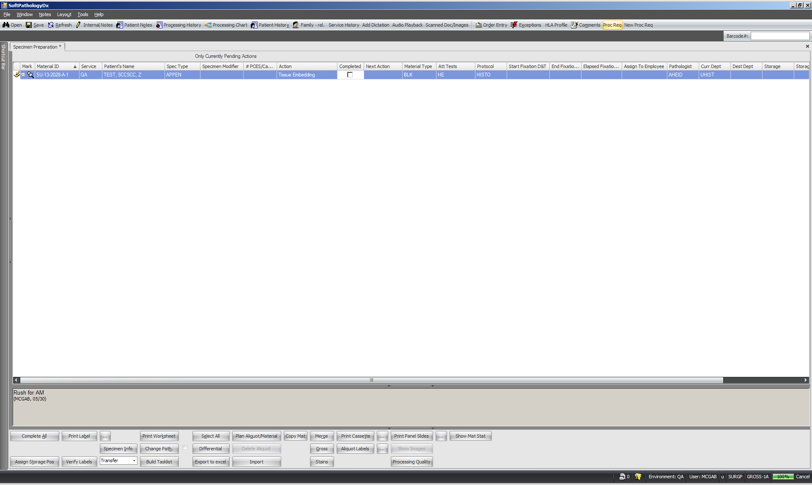

Click “Add”.

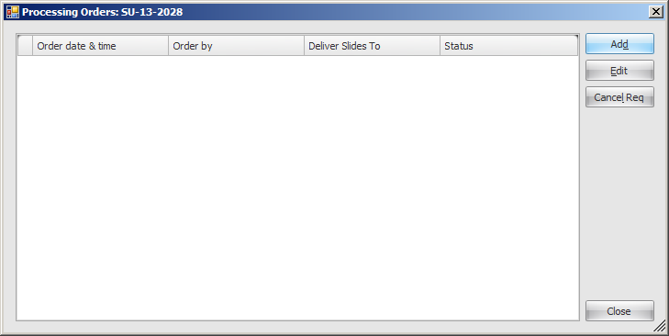

Click “Add Slides”.

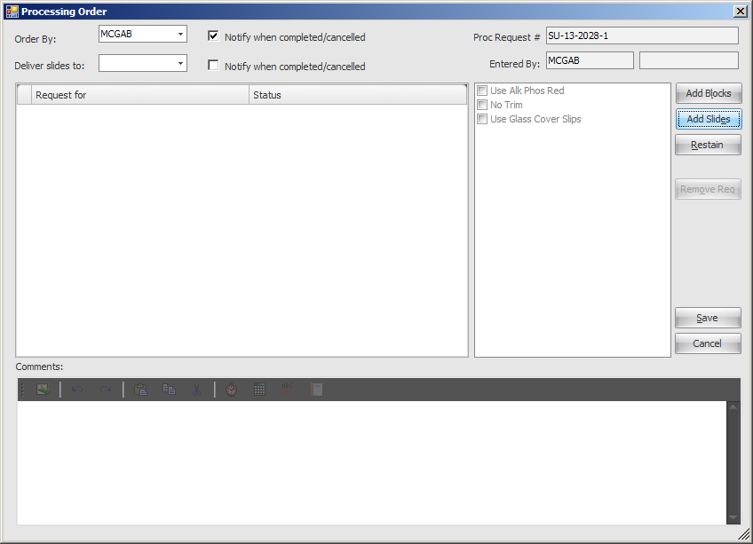

Click “materials” and check which cassettes you want stains ordered on. Click “ok”.

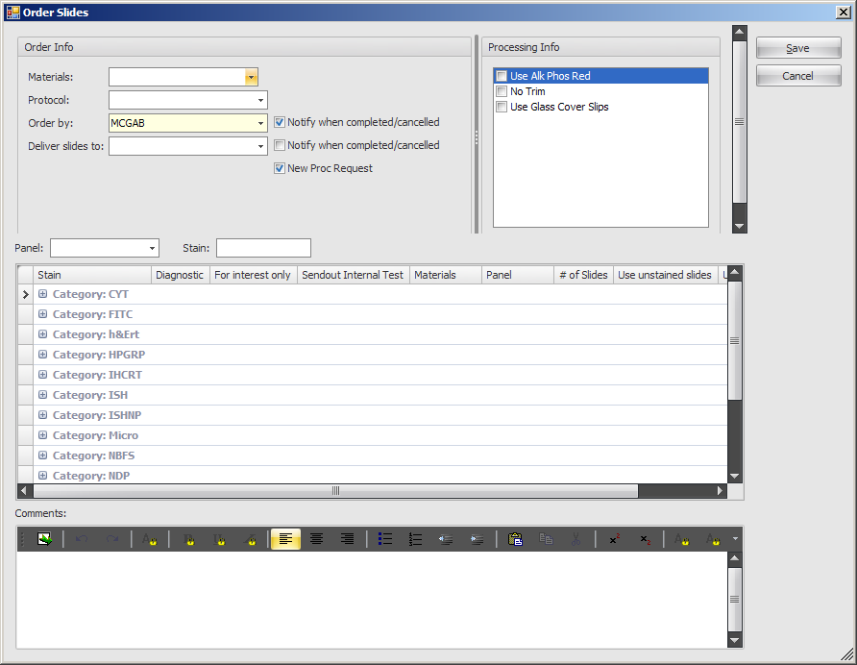

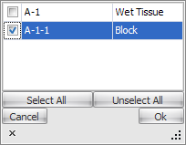

Go to “deliver slides to” and choose which attending or service you want the slides to go to. Click “ok”.

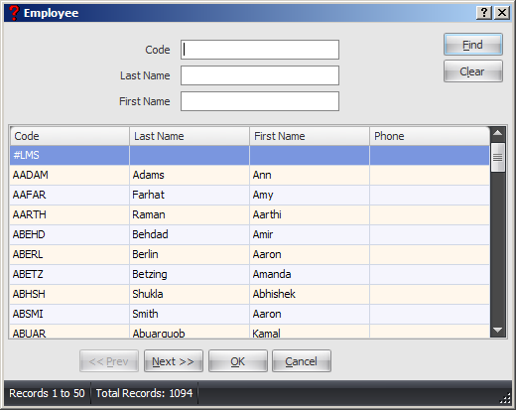

Choose either a panel or individual stain. Individual stains need to be typed in upper case letters. Check the stains you want, type in any comments below and click “save”.

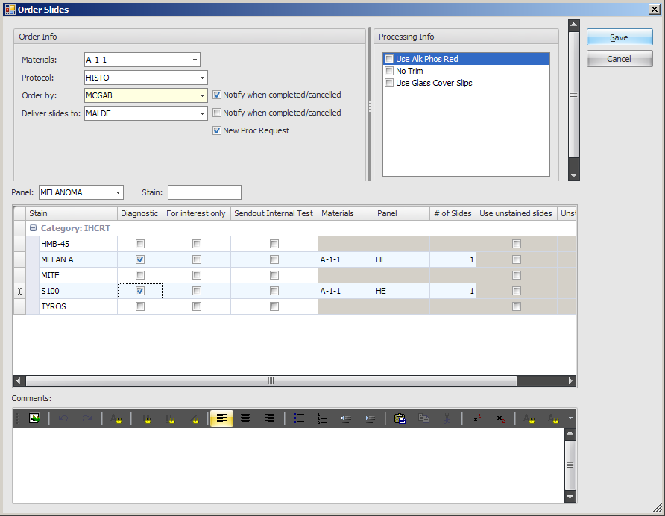

This screen shows which stains were ordered. Click “Save” and close the following window.

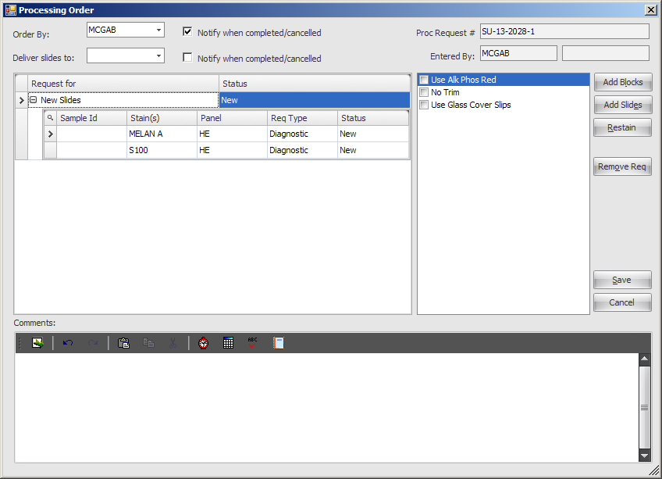

Change the action of your cassette from “pull material” to “send blocks to UHIST”, check the box and save.

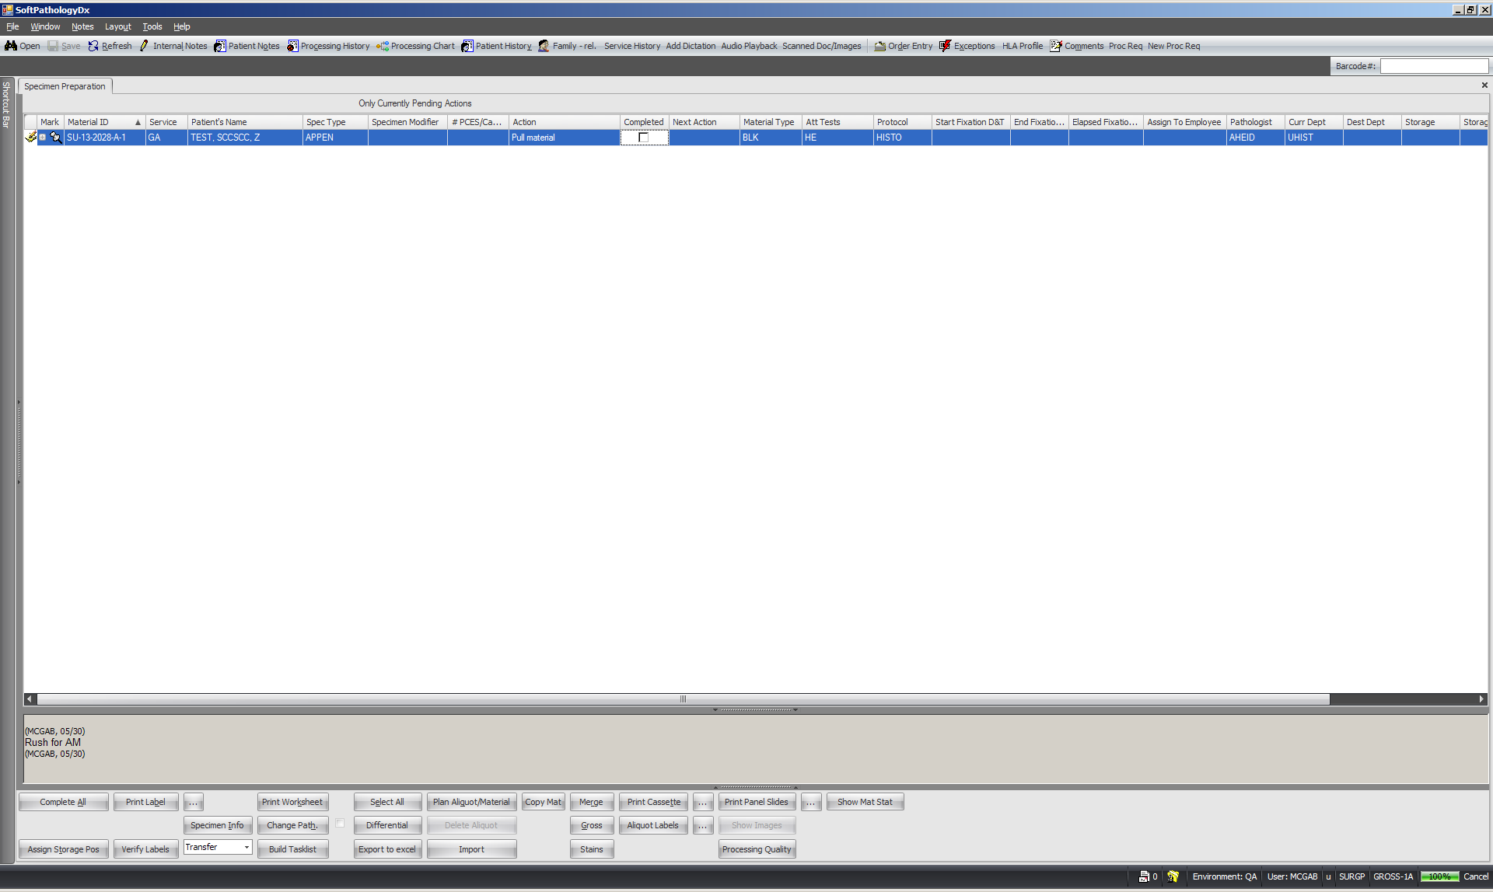

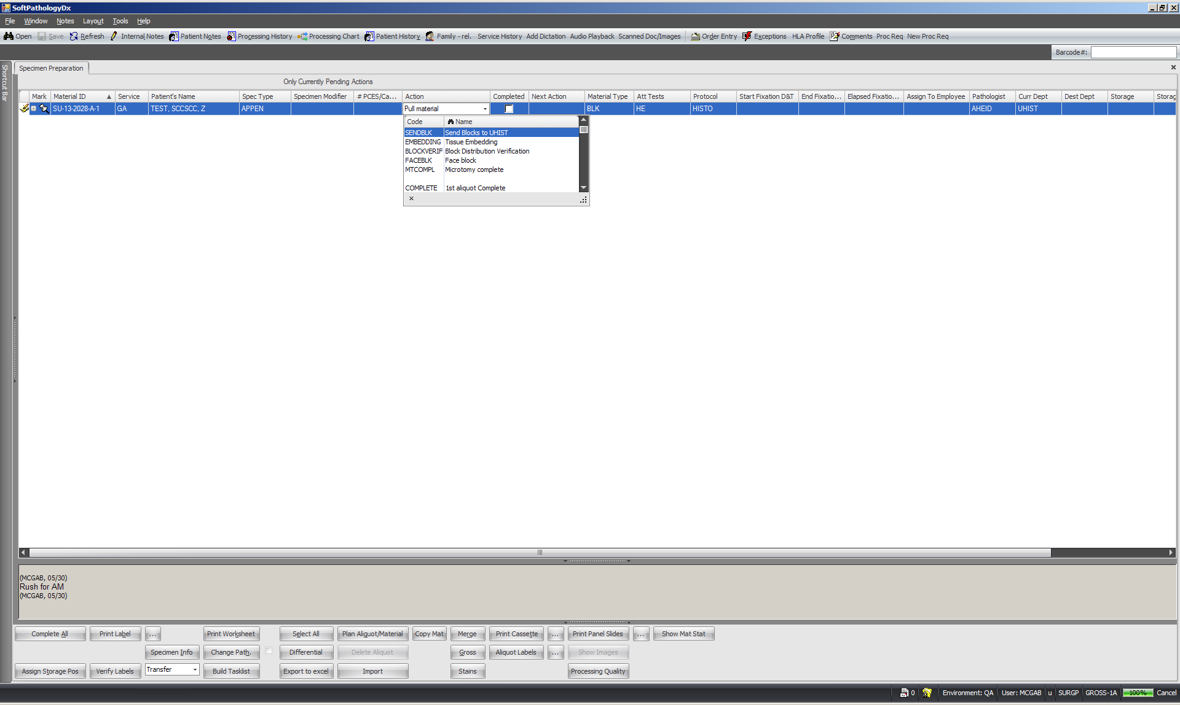

Congratulations, you’ve just ordered stains.

