Purpose
To establish a procedure on how to gross bowel for non-neoplastic diseases.

Procedure
Triage the specimen
- Look at patient history to identify why the segment was removed
- Take photos of fresh specimen- serosa and mucosa
- Open the specimen along the antimesenteric aspect
- Gently rinse mucosa free of fecal material and other debris
- Pin specimen out on a board or lay flat between gauze for optimal flat fixation
Grossing/dictating the specimen
- Is the specimen oriented?
- State what you have- terminal ileum? Cecum? Small intestine? Proximal ascending?
- Measure the specimen(s)- length and internal circumference
- Describe the serosa (adherent adipose tissue? Defects? Color- dusky? Adhesions?)
If defect is present, measure defect to nearest margin (or both margins if oriented)
- Describe the mucosa (edematous? Dusky? Flat or folded? Stricture in lumen?)
- Describe any other gross findings.

Sections for Histology
- Take longitudinal sections of bowel, perpendicular to mucosal folds representing all mentioned gross abnormalities (diverticulae, perforation, strictures, etc.)
- If appendix is received, take standard sections of appendix.
- Any other abnormalities or structures (i.e. mesenteric abscess, ostomy, etc.)

Sample Dictations and Photographs
Received in formalin in a medium sized container labeled “ostomy” is a 5.2 cm in length segment of small intestine with an internal circumference of 3.6 cm. The serosa is pink tan, with a moderate amount of adherent fibroadipose tissue. One end is remarkable for a patent ostomy site surrounded by skin and granulation tissue. The mucosa herniating from the ostomy site is thickened and hyperemic. No other gross abnormalitites are identified.
Cassette Summary:
A1- perpendicular sections of ostomy site including skin. (2ss)
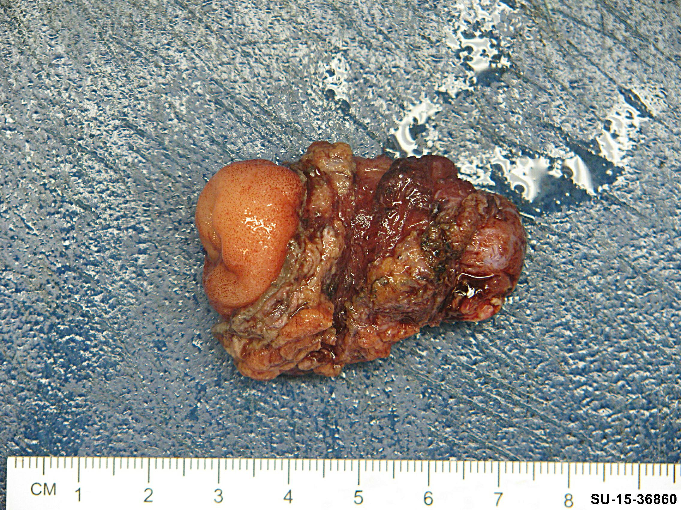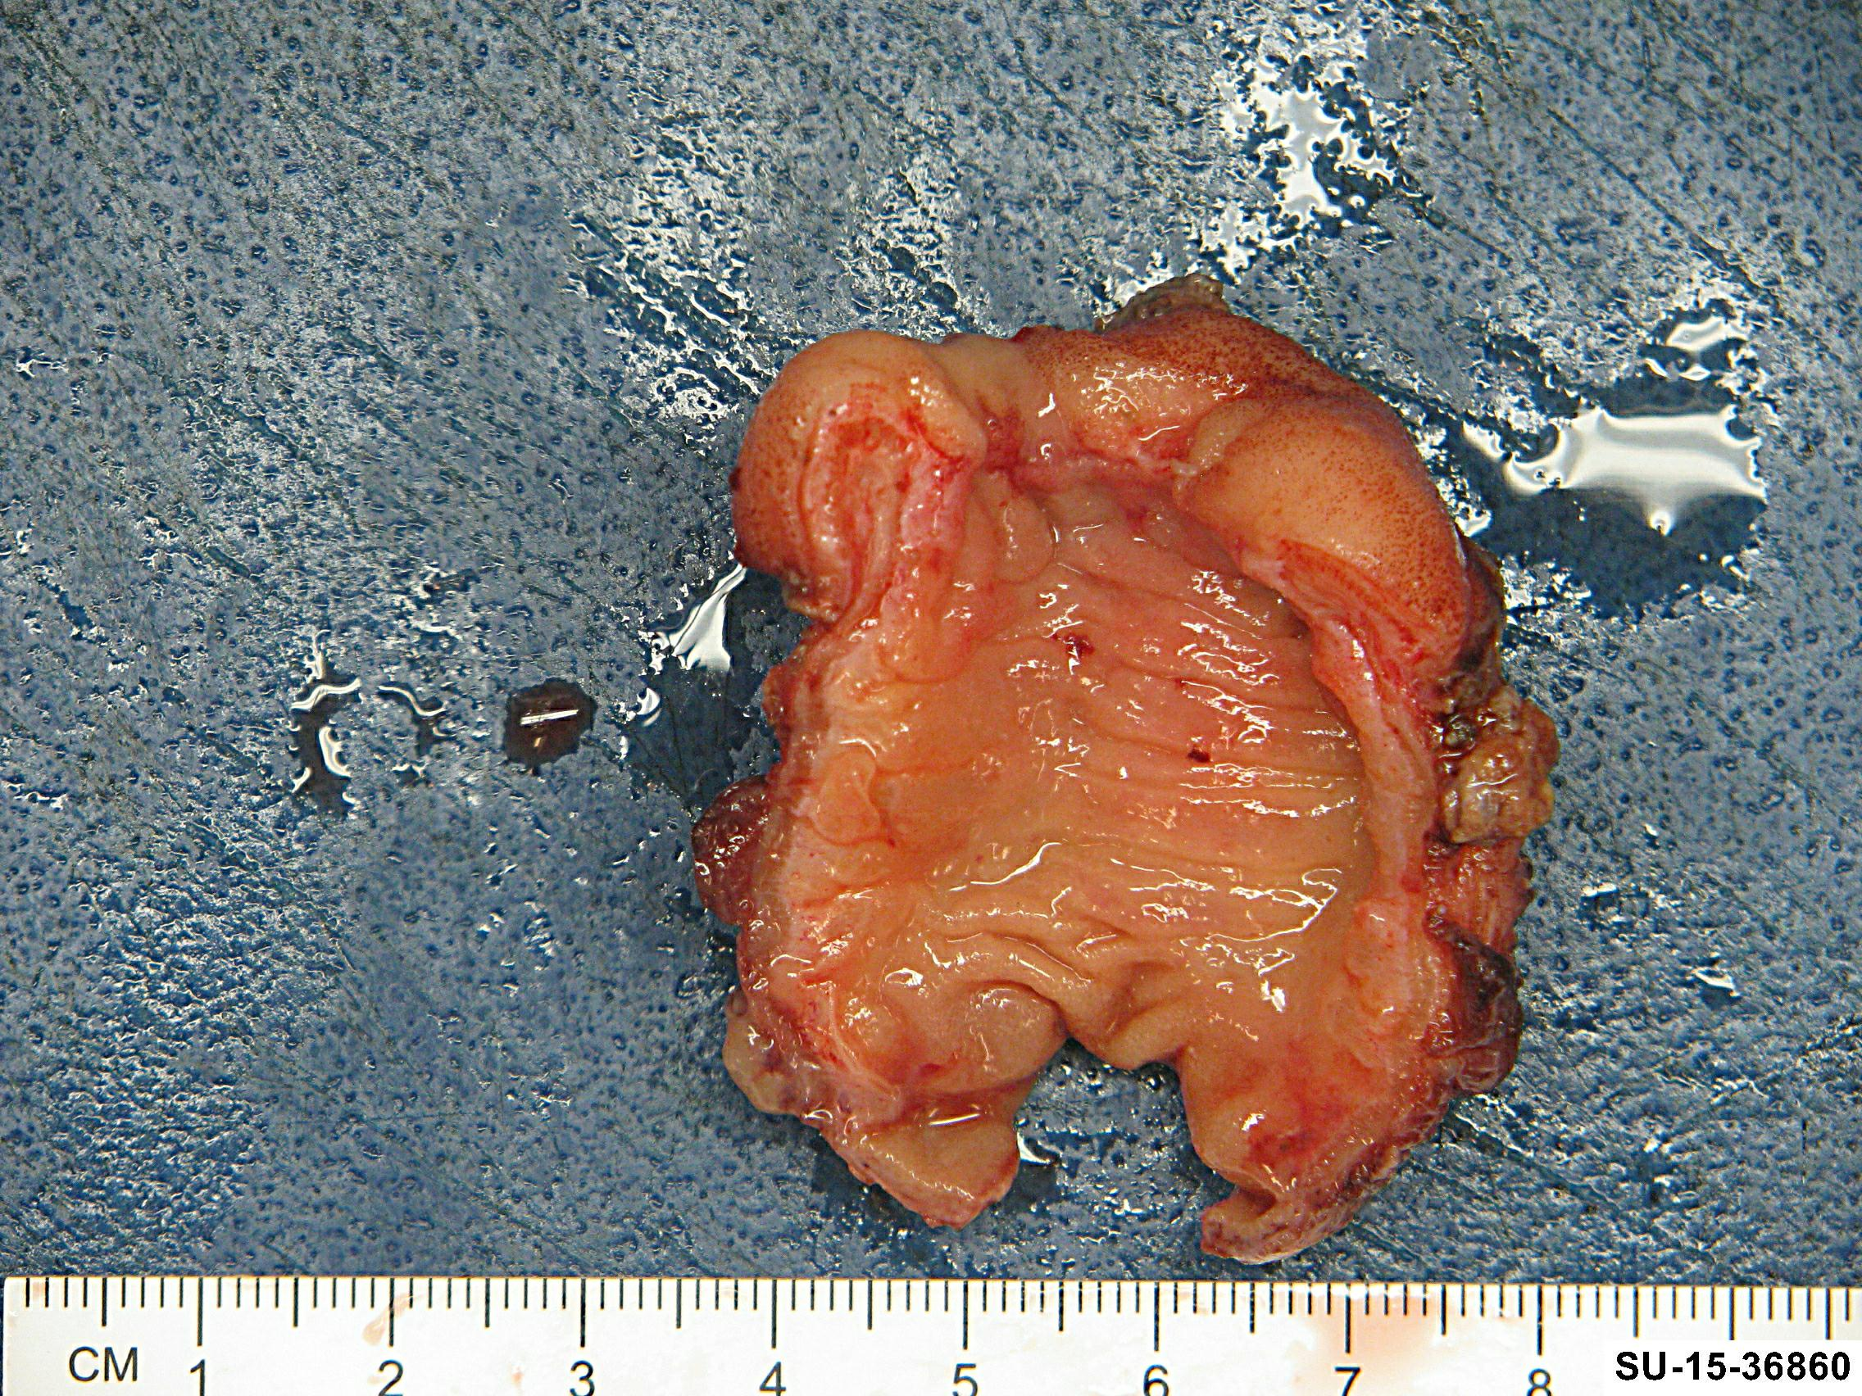

"Infarcted bowel and abscess - distal ileum" Received in formalin in a small container is a 14.3 cm in length loop or adherent bowel with an internal circumference ranging from 0.7 cm up to 2.5 cm. The serosa is purple-tan, dusky with fibrous adhesions and remarkable for a 0.8 x 0.5 cm transmural defect located 5.3 and 4.5 cm from the margins of resection. Adherent to the serosa surface along the defect is a 2.5 x 1.1 cm possible abscess cavity filled with purulent fluid. There is a stricture in the lumen constricting the internal circumference to 0.7 cm. Proximal to the perforation, the lumen is dilated with diffusely hemorrhagic, dusky mucosa with absence of normal folding pattern. The remaining mucosa is unremarkable.
A1. Perpendicular sections of defect. (1ss)
A2-A4. Adherent possible abscess cavity. (1ss)
