Purpose
To establish a procedure on how to gross both biopsies and endorectal pull through resections for Hirschsprungs disease.

Procedure
Frozen Section
- Orient the specimen on edge to obtain full thickness sections ***do not use the freeze bar. This will flatten the section and distort orientation!
- If larger than 0.3 cm, bisect and submit one half for permanent sections.
- Cut six levels, one section per slide

Rectal Suction Biopsy
- The specimen is accessioned as a “PEDRECBX = pediatric rectal biopsy (Hirshprung’s)” and is processed as a rush in an orange cassette. This protocol consists of 2 HE slides (with 8-10 serial levels) from each block and 1 calretinin stained slide.
- Process the specimen one piece per cassette. (usually 2-3 pieces are received)
- Orientation is key. Place the tissue on a piece of cardboard mucosa side up. Wrap the cardboard in lens paper. Place the lens paper in a biopsy bag. Place the biopsy bag in the cassette.
- Create an Internal Note in soft to alert histology to embed the specimen on edge. For example: “Specimen is submitted in cassette mucosa side up. Please rotate tissue 90 degrees and place on edge.”
- Alert the main histology, lab by calling 6-6818, that you have a rush Hirschsprung biopsy and arrange for the cassettes to be picked up for same day processing.
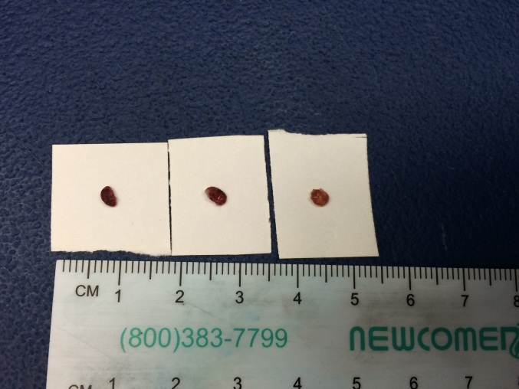
- Place on cardboard mucosa side up
2. Wrap cardboard in lens paper
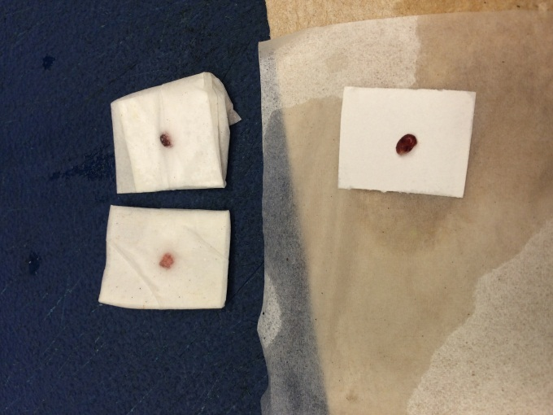
3. Place wrapped cardboard in biopsy bag and place in cassette
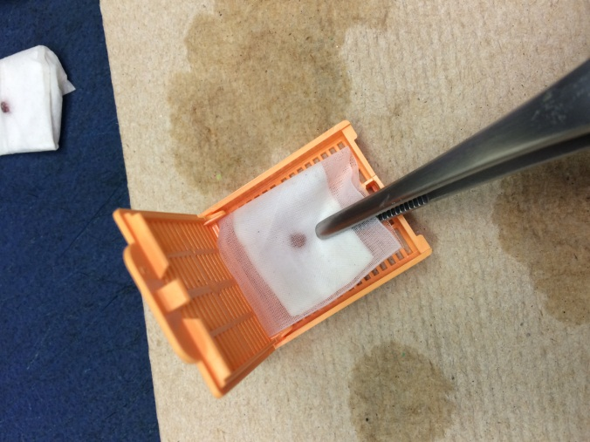

Open Rectal Biopsy
- The specimen is accessioned as a “PEDRECBX = pediatric rectal biopsy (Hirshprung’s)” and is processed as a rush in an orange cassette. This protocol consists of 2 HE slides (with 8-10 serial levels) from each block and 1 calretinin stained slide.
- Document orientation by surgeon (ink)
- Cut perpendicular
- Put each section in one cassette with orientation on edge

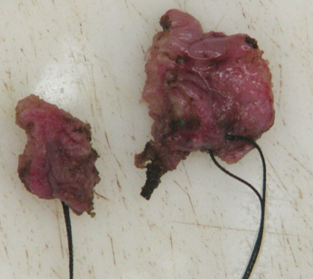

Endorectal Pull-Through
- The specimen usually consists of segment of colon- full thickness bowel proximally and mucosal/Submucosal tube distally
- Orient the specimen (usually multiple sutures are received on one end designating distal)
- Open the specimen and pin out or fix flat for ideal sectioning
- Photograph both serosal and mucosal surfaces
- Measure the length and internal circumference of the segment received
- Describe the serosal surface
- Evaluate the mucosal surface. Is a transition zone or previous biopsy or frozen site identified?
- Shave the proximal margin, submitting the entire margin on edge (this may require 2-3 blocks) **This is to confirm the proximal margin is normally ganglionic.
- Submit one complete longitudinal section from proximal to distal margin, including prior biopsy sites. Put one piece per cassette and ink the proximal end of each piece the same color to maintain orientation.
- Annotate sections submitted on photograph (see below).

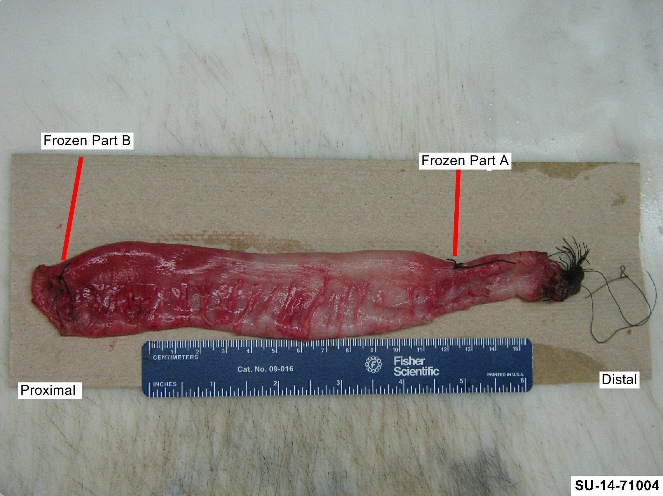
Sample Description
"Endorectal pull-through" Received in formalin in a medium container is a 20 cm segment of intestine, 6.5 cm in circumference. The distal end contains sutures and is 2.2 cm in circumference. There is a stitch, 6 cm from the distal margin, that designates frozen section part A and a stitch, 0.1 cm from the proximal margin that designates frozen part B. Samples of the proximal margin is submitted for frozen section in frozen sections FS1-FS4. The serosal surface and mucosal surface are unremarkable. No lesions noted.
DFS1-4. Representative sections of proximal margin, shaved and submitted en face. (1 ss each)
D5-17. Longitudinal full thickness sections, submitted from proximal to distal with distal ends inked blue in each section. Cassette 5 contains area adjacent to frozen Part B and Cassette 15 contains area adjacent to frozen section part A. (1 ss each)

