**Purpose**

To establish a procedure on how to process renal resections for Wilms tumors.

**Materials**

* One (1) conical glass tube containing cytogenetics medium for cytogenetics
* One (1) small plastic vial filled with Roswell Park Memorial Institute (RPMI) medium for chromosome microarray analysis (CMA)
* At least four (4) empty small plastic vials to snap freeze tissue in for COG studies
* One (1) dewar containing liquid nitrogen (LN2)
* One (1) extra-long forceps for removing tissue vials from LN2
* Additional requisition and specimen labels
* One (1) additional copy of the original surgical pathology requisition
* One (1) cytogenetics requisition
* One (1) small specimen bag

**Procedure**

1. Photograph the external kidney.
2. Weigh and measure the kidney in 3 dimensions.
3. Examine and describe the capsule, documenting any sites of rupture or penetration by the tumor.
4. Examine and describe the hilum. Is there tumor thrombus in the renal vein? Sample the vascular and ureteral margins.
5. Examine the renal sinus for tumor invasion.
6. Ink the capsule, making sure to ink areas of rupture or suspected capsular invasion a different color from the rest. Bivalve the kidney through the hilum and photograph the cut surfaces.
7. Obtain multiple (2-6 based on available tumor) samples (at least the size of an eraser on a pencil) of viable tumor. Place 1 sample in cytogenetics medium for cytogenetics and the other in RPMI for cytogenetic microarray.
8. Obtain 2 samples of viable tumor and 2 samples of normal kidney and snap freeze in liquid N2. COG protocol calls for 10 g of tumor and normal kidney, each, however this is dependent upon the amount of tissue available.
9. After labeling the samples for cytogenetics and microarray, place them in a small specimen bag, along with a copy of the surgical pathology requisition and a completed cytogenetics requisition, and place in the refrigerator in the red bin labeled “Specimen Pickup”.
10. After labeling the samples for COG studies, place them in the -80°F freezer in the most up-to-date labeled “PTP” box (PTP-YEAR-#). In the Pediatric Tumor Protocol logbook (located on the shelf above the accessioning computer) document the case number and part, the number of samples taken, and in which box the samples were placed.
11. Place the specimen in an adequately-sized container filled with formalin and allow it to fix for at least 2 hours. Place paper towels in between slices to facilitate fixation. You may have to use more than one container if the specimen is too big, one container for the slice you will be using for sections and one for the rest of the specimen.
12. Remove the kidney from formalin. Make additional cuts parallel to the original cut on either side at intervals of 1.5 to 2 cm. Describe the appearance and location of the tumor, documenting it’s involvement of other structures. If the tumor was treated, document the percentage of grossly viable versus necrotic tissue.
13. Most of your sections for histology should come from the periphery of the tumor to show the relationship of the tumor to the renal capsule, renal parenchyma, and renal sinus. Submit a minimum of one generous section of tumor per centimeter of the tumor’s greatest dimension. Any area of tumor that appears different from the rest should be sampled. Normal renal parenchyma should be sampled generously. Look closely for any distinct irregularities in the normal renal parenchyma, as these may represent nephrogenic rests.
14. Be sure to map out and annotate your sections on the images taken in Soft.

**Summary of sections for histology:**

* + Tumor to renal capsule
  + Tumor to normal renal parenchyma
  + Tumor to renal sinus
  + Triangular areas (areas of uninvolved renal parenchyma adjacent to tumor-capsule interface—*see first image below*)
  + Each nodule, if multifocal
  + Resection margins
  + Normal kidney and ureter
  + If present: adrenal gland, lymph nodes, other vessels

**Sample Dictation**

A. “left kidney” Received fresh for pediatric tumor protocol in a large container is a ___-g, __ x __ x __-cm kidney with an attached segment of ureter (__ x __ cm), renal vein (__ x __ cm), and renal artery (__ x __ cm). The capsule is red-tan, smooth, glistening, and freely movable. The hilum and renal sinus are unremarkable. No lymph nodes are identified. The capsule is inked blue and the kidney is bivalved to reveal a well-encapsulated mass with tan, focally hemorrhagic, mixed solid and cystic cut surfaces (__ x __ x __ cm) located in the upper pole. The mass abuts, but does not appear to invade, the renal capsule, renal calyces, and renal sinus. The uninvolved renal parenchyma is red-tan and unremarkable, with well-defined corticomedullary junctions. The renal calyces and sinus are lined by unremarkable, tan, smooth and glistening mucosa. The ureter is lined by unremarkable, tan, glistening mucosa arranged in longitudinal folds. Samples of the tumor are sent for cytogenetics and chromosome microarray analysis. Additional samples of tumor and normal renal parenchyma are snap frozen and placed in the freezer for COG studies.

Cassette summary:

A-1. Vascular and ureteral margins (3ns)

A-2 and A-3. Triangular areas (1ss ea.)

A-4 through A-9. Peripheral tumor to include adjacent capsule in A-4 and -5, adjacent normal renal parenchyma in A-6 and -7, and adjacent renal sinus in A-8 and -9 (1ss ea.)

A-10 and A-11. Central tumor (2ss ea.)

A-12. Normal renal parenchyma, including cortex, medulla, and calyx (1ss)

**Sample Photographs**

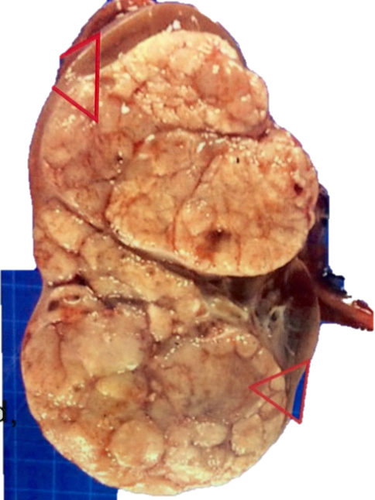Above-See triangular areas showing normal renal parenchyma to tumor/capsule interface.

