**Purpose**

To establish a protocol for grossing pediatric liver tumors.

**Procedure**

* Photograph specimen, including cut surfaces. Annotate photographs as to where you sample for future reference.
* Measure in three dimensions and weigh (after removing gallbladder).
* Section liver parallel to its long axis, showing greatest surface area.
* Perform pediatric tumor protocol, if received fresh.
* Allow sections to fix by transferring specimen to larger container. Make sure each section is exposed to adequate formalin so the center doesn’t autolyze.
* Identify, examine and then submit an enface shave section (complete cross section) of porta hepatis margins.
* Describe capsular surface.
* For hepatic parenchymal tumors: if there is a parenchymal surgical margin, ink before sectioning. Describe size, color; consistency; margins; relationship to capsular surface, major vessels (portal and hepatic veins) and biliary tree; distance to surgical margin; multiplicity; appearance of non-neoplastic liver (congested? signs of biliary obstruction? cirrhosis?)
* For tumors of major bile ducts: as mentioned, identify all of the bile duct and vascular surgical margins (with the help of the surgeon, if necessary), and submit them enface; palpate the bile ducts for areas of induration; open the major bile ducts longitudinally with scissors; after taking photographs, serially section the bile ducts perpendicularly to their long axes; search for hilar lymph nodes. Describe tumors same as for hepatic parenchymal tumors, plus: intraductal papillary component? ductal stenosis or dilation? biliary stones?
* Gallbladder: if present, describe as per instructions in Gallbladder – cholecystectomy; relationship with hepatic parenchymal or bile duct tumor.
* Hilar lymph nodes: if present, describe number, size, and appearance.

***Sections for Histology***

* Surgical margins: these should be taken from the areas that appear grossly closer to the tumor. In the case of the tumors of major bile ducts or explants, one of these sections should be an enface view of the bile duct and vascular surgical margin (porta hepatis).
* Tumor: multiple sections (about 1 per each cm of largest dimension), majority from periphery of tumor showing relation with adjacent liver. All grossly dissimilar areas should be sampled. If several nodules are present, samples of several nodules should be taken. Unless excessively large, tumors of major bile ducts should be submitted in toto.
* Non-neoplastic liver: include portions distal and proximal to the tumor, if feasible. Be sure to include sections of capsule.
* Gallbladder, if present; one section.
* Lymph nodes, if present: in their entirety.

***Sample dictation***

"Segment 5-6 liver mass" Received in formalin in a large container is a 197 gram, 11 x 8 x 6 cm portion of liver remarkable for a 6 x 6 x 5 cm well-circumscribed and encapsulated mass with yellow-brown, homogeneous, solid, and soft and friable cut surfaces. The mass comes to within 0.1 cm of the nearest parenchymal resection margin (inked blue). Capsule overlying mass is inked green. The uninvolved hepatic parenchyma is red-brown and grossly unremarkable.

Cassette summary:

B1-B7. Representative sections of mass, with closest resections margins in B1 and B2, adjacent uninvolved parenchyma in B3 and B5, and overlying capsule in B4 and B6. (1ss each) B8. Uninvolved hepatic parenchyma. (1ss)

Note: Annotated photographs provided for reference.

***Sample Photographs***

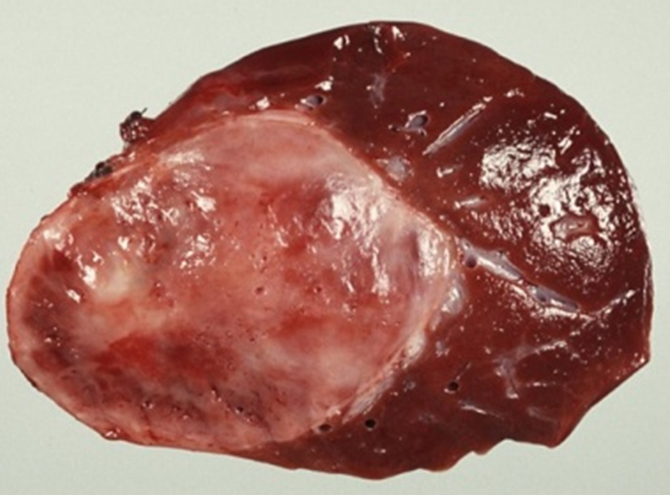



Be sure to ink your hepatic margin of resection!