Purpose
To establish a procedure on how to gross an Osteochondromas (a.k.a. exostosis).
Procedure
- Measure specimen in 3 dimensions making note if the tumor is pedunculated or sessile.
- Serial section along the longitudinal plane using the band saw.
- Describe the cut surfaces including thickness of cartilaginous cap (maximum thickness).
- Take photographs.
Sections for Histology
- Submit 2-3 representative sections including the cartilaginous cap and any irregularities within the cancellous or compact bone. Note: These tumors need to be adequately sampled to check for malignant transformation.
- If a malignancy is suspected, include at least one cassette of the inked margin. Make sure to decal cassettes before submission.
Sample Dictation
“Right distal femur ", Received in formalin in a small container is a 5.5 x 2.6 x 1.9 cm pedunculated and exophytic bone mass, which is partially surfaced by a cartilaginous cap (0.8 cm in greatest thickness). Serially sectioned to reveal grossly unremarkable compact and cancellous bone. Photographs are taken for future reference.
A1. Bone mass including cartilaginous cap in each cassette. (1ss after decal)

Sample Photographs

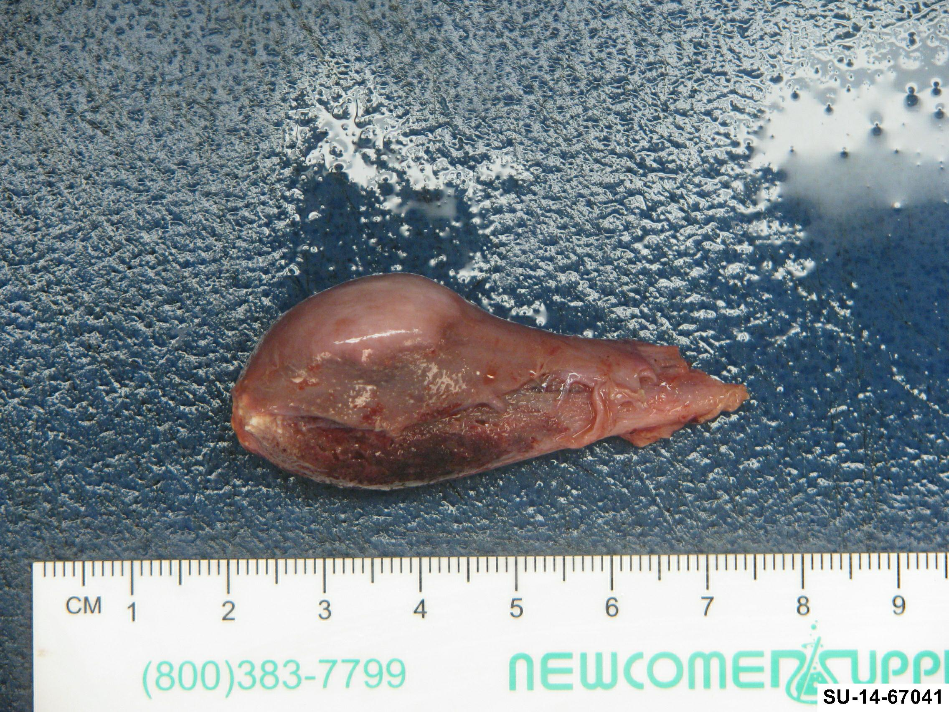
Photo of a pedunculated osteochodroma taken from the femur of 14 year old male.

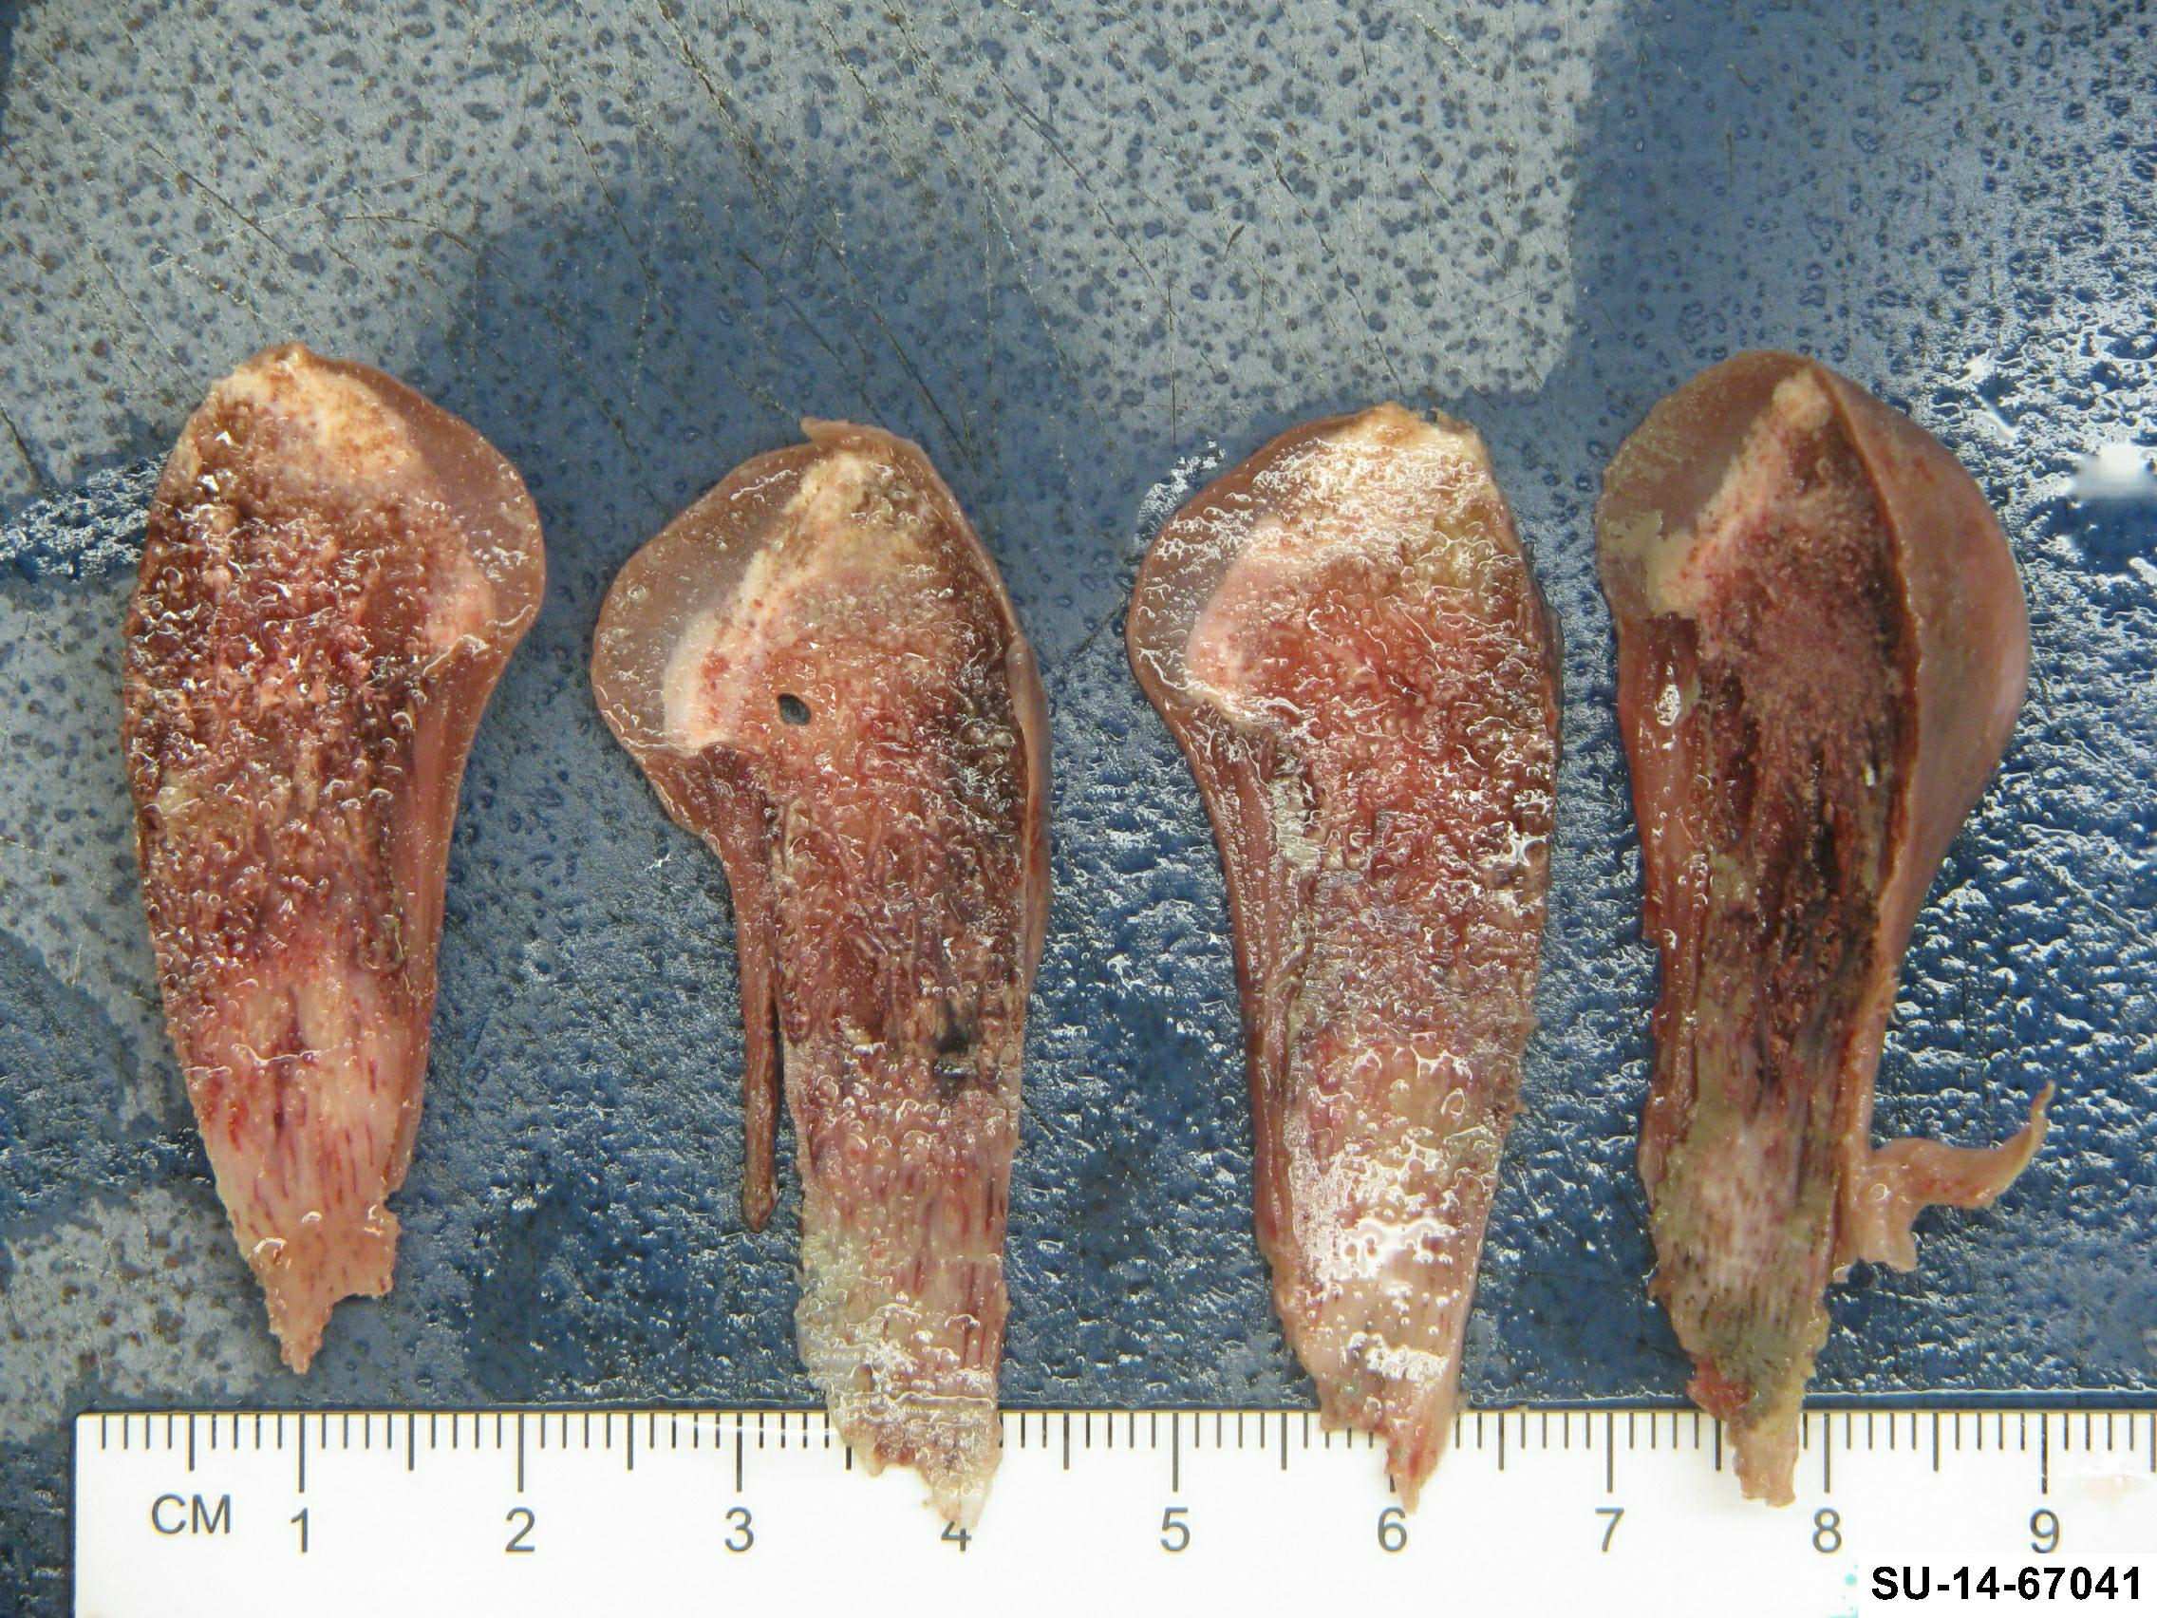
Notice the cartilaginous cap covering the tip of the specimen.

