**Purpose**

To establish a procedure on how to properly process pediatric biopsies/soft tissue cores to maximize quality and yield for histological exam.

**Materials**

* 10% neutral buffered formalin
* Eosin
* Tissue swabs
* Lens paper
* Biopsy bags
* Cardboard or heavy paper cut out into 2.0 x 2.0 cm pieces.

**Procedure**

1. If the tissue is for frozen and/or tumor protocol, be sure to saturate the cores in flow media to prevent drying out. If possible, allow tissue cores to fix in formalin for at least 1-2 hours before histological processing. For Pediatric Tumor Protocol, please see Master Control Document **GROSS-PROC-0119**.
2. Lay out all cores and photograph.
3. Describe the number of cores and give a range in length and diameter.
4. Use a swab to apply eosin to each core.
5. Place tissue on cardboard piece, wrap in lens paper and place in biopsy bag. Place wrapped bundle in cassette. **Note: Do not put more than 1 core in a cassette.**
6. Indicate the number of pieces in each cassette through SoftPathDx.
7. Use internal notes to convey any important information to histology.
8. Most cores should be treated as a RUSH. Please discuss with your attending.
9. Place cassettes in a designated rack for small biopsies. If processed with other large specimens, tissue may be compromised.

*See sample photographs below showing step by step procedure.

***Sample Photographs***

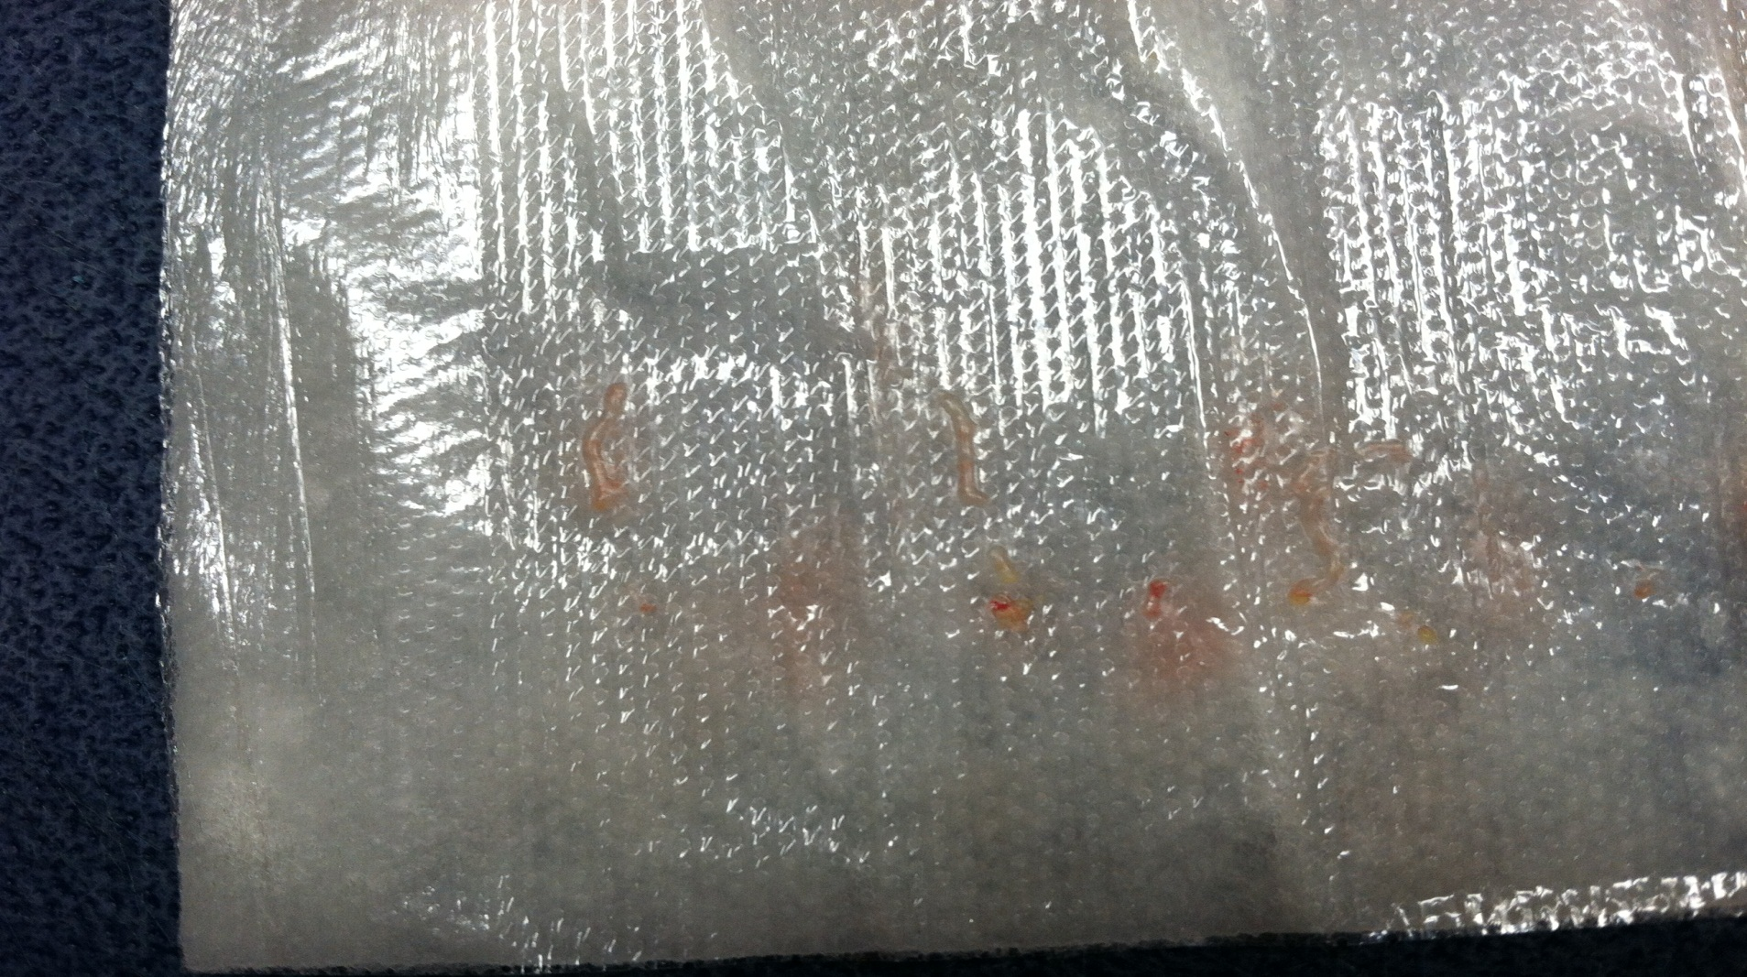

* Tissue cores usually come attached to telfa pads. Make sure all cores are accounted for and photograph before proceeding. Use flow media to moisten telfa pad and cores if triaging for tumor protocol.

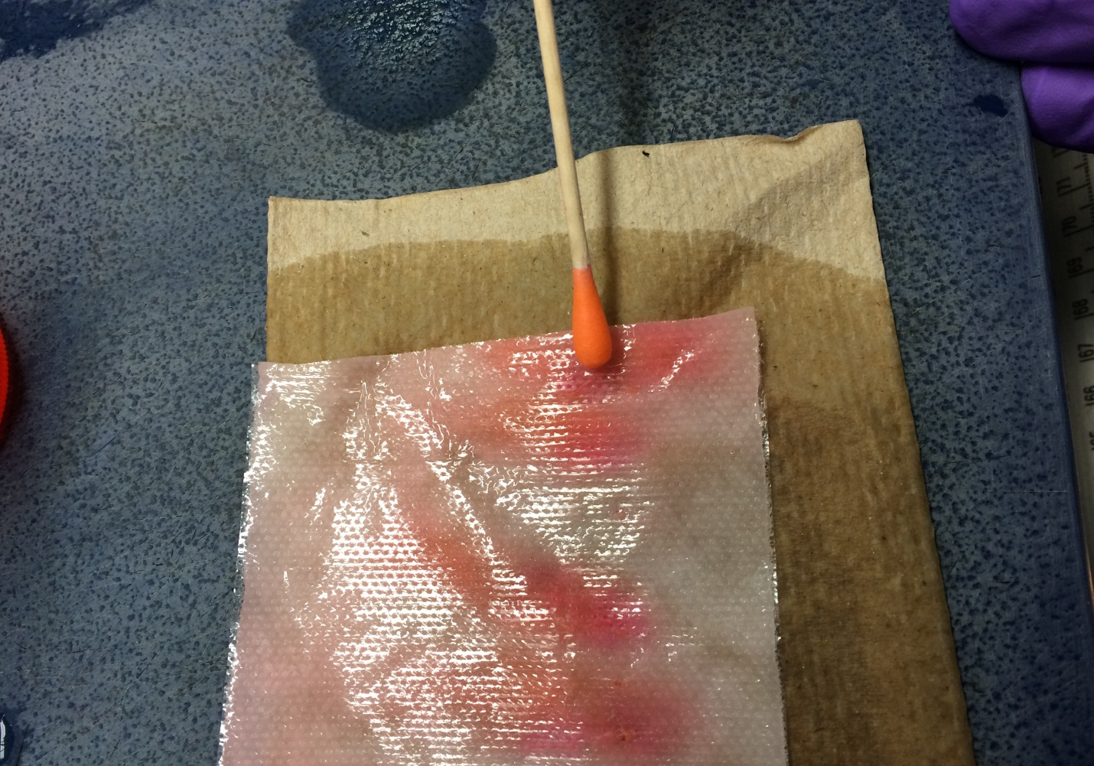

* Gently dab eosin on cores so they are easily seen for not only grossing purposes but for embedding and cutting down the line.

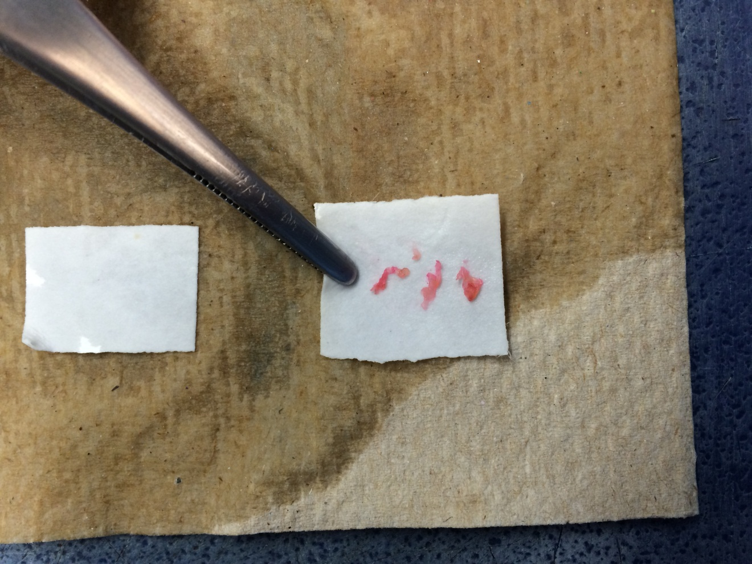

* Place tissue on cardboard, no more than 3 per cassette.

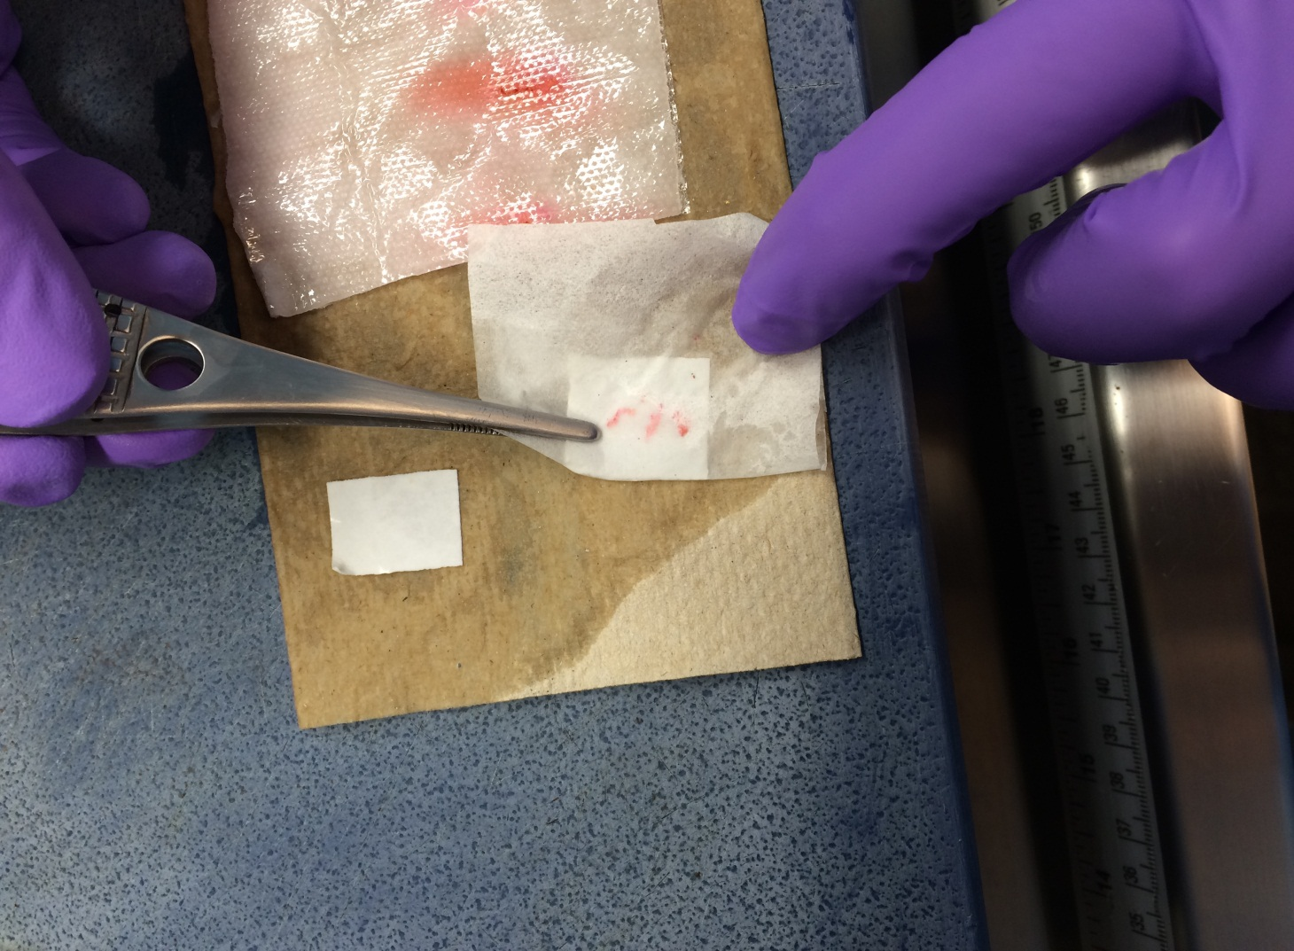

* Wrap cardboard with tissue in one sheet of lens paper. Use a water to moisten the lens paper as this will aid in manipulating folds.

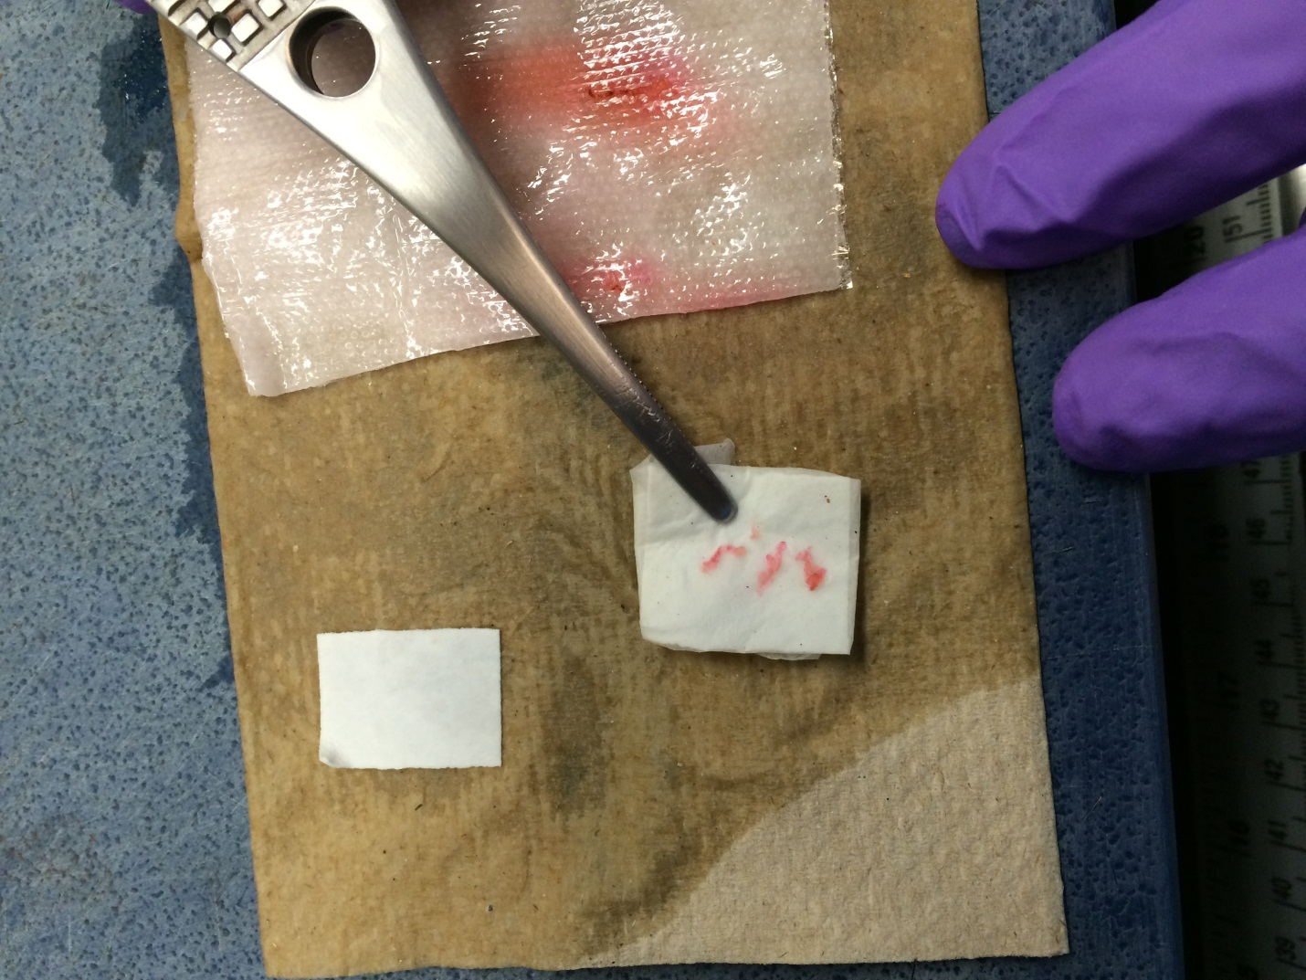

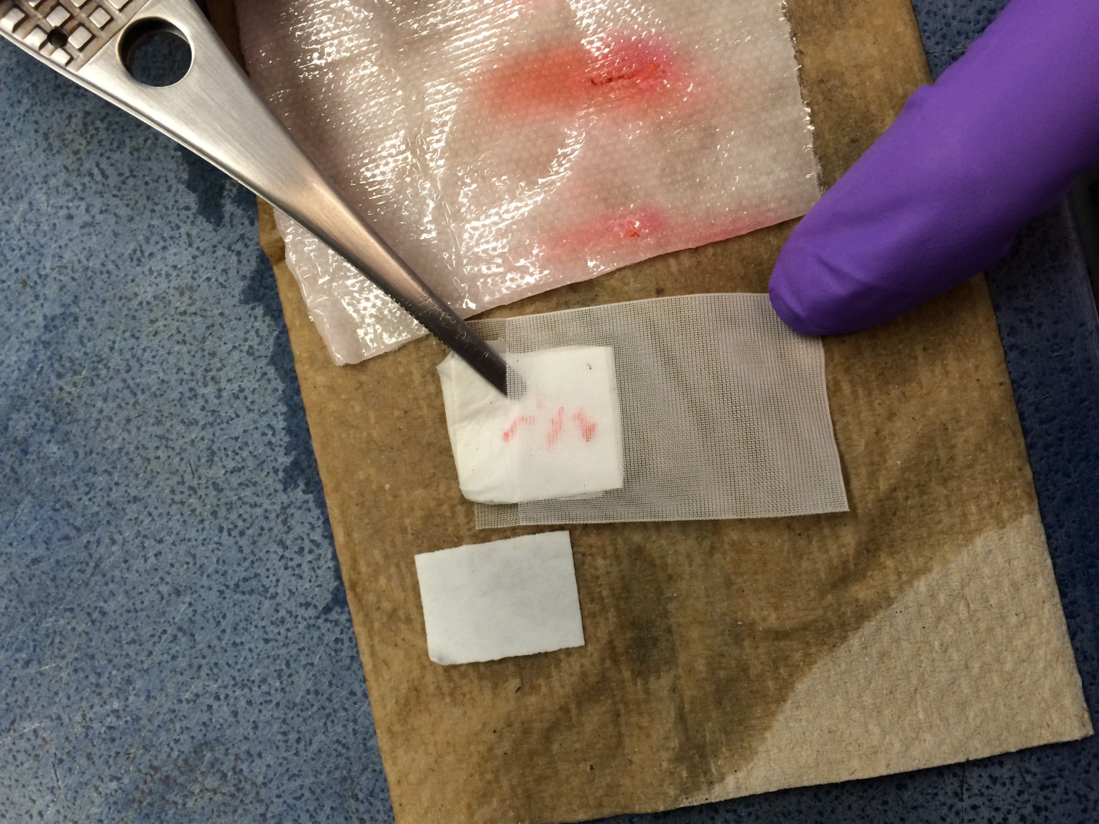

* Place bundle in lens paper.

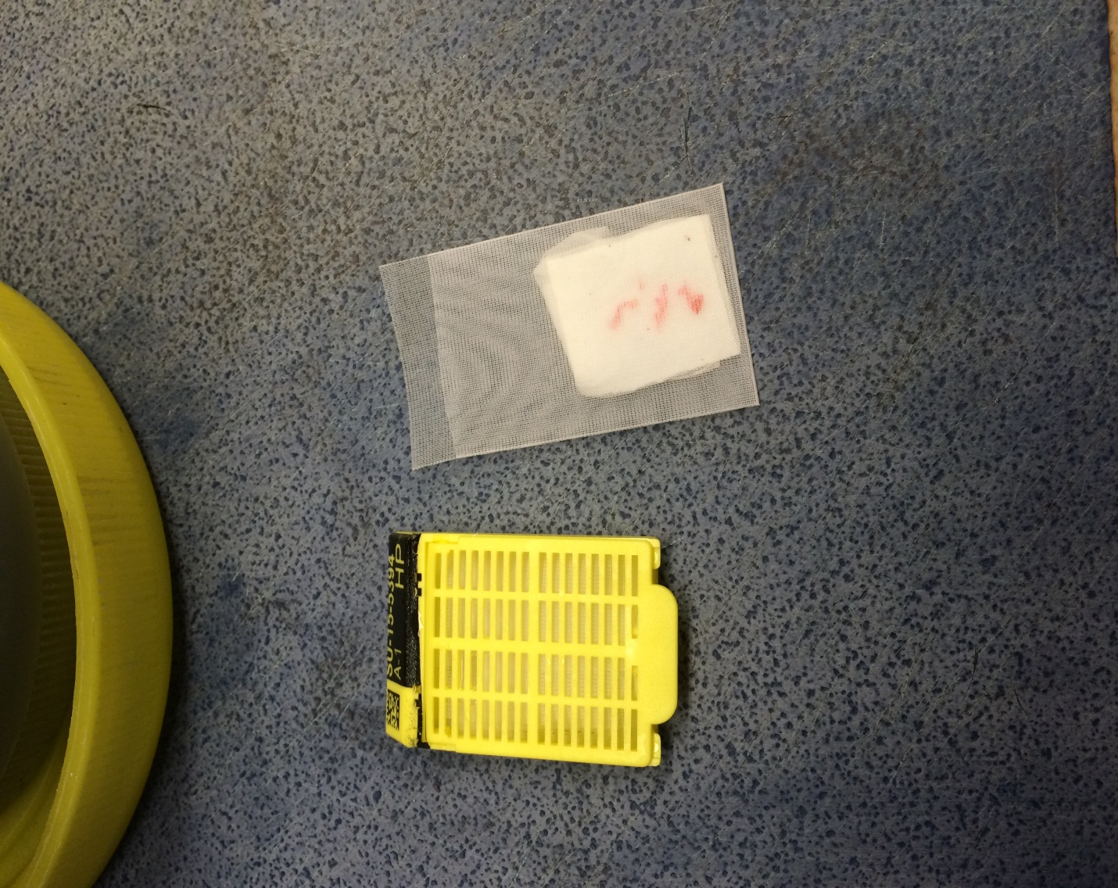

* Place bag in cassette and make sure to put on rack for designated biopsy processing.